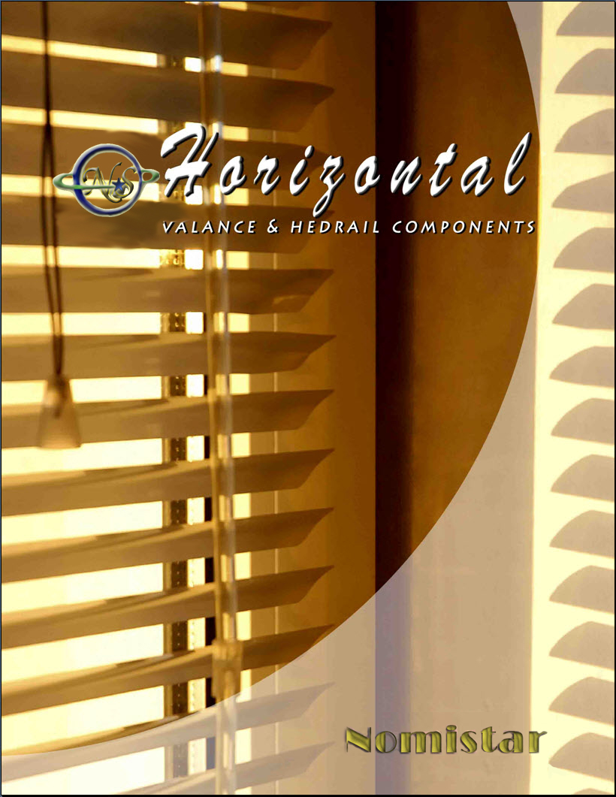
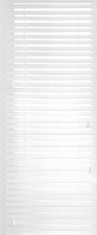

NOMISTAR HORIZONTAL COMPONENTS

VALANCES & HEADRAIL SYSTEMS

Contents

Horizontal Valance Components ………………..... 2

Low Profile Headrail System …………………...… 6

High Profile Headrail System …………………...... 9

Common Parts and Accessories …………………... 12

Order Form ……………………………………….. 16

Warranty …………………………………….......... 17

Cornice Valance

D
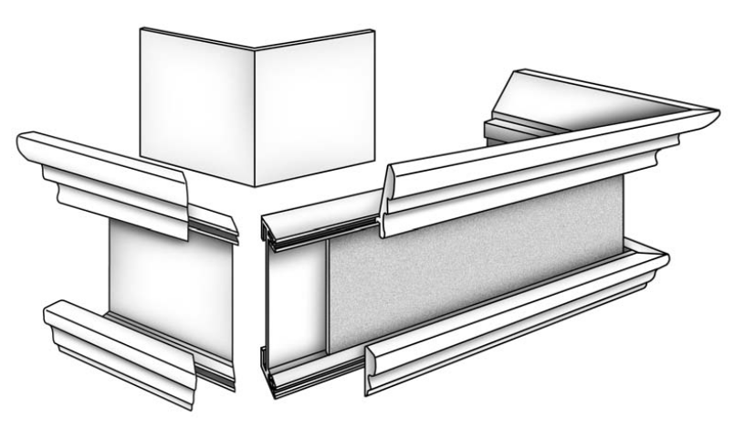
A. Executive Valance 2"
B. Renaissance Cornice Trim
C. Colonial Cornice Trim
D. Inside Cornice Corner
E. Any 2” Louver or Slat
C

E

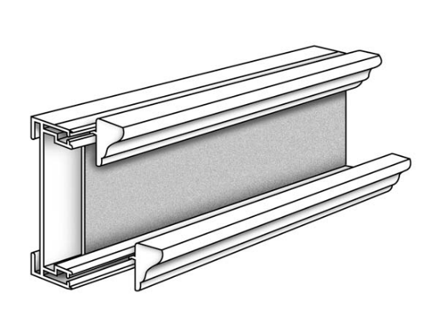
A

B
B
Outside Mount

A

E

Inside Mount

Executive Valance

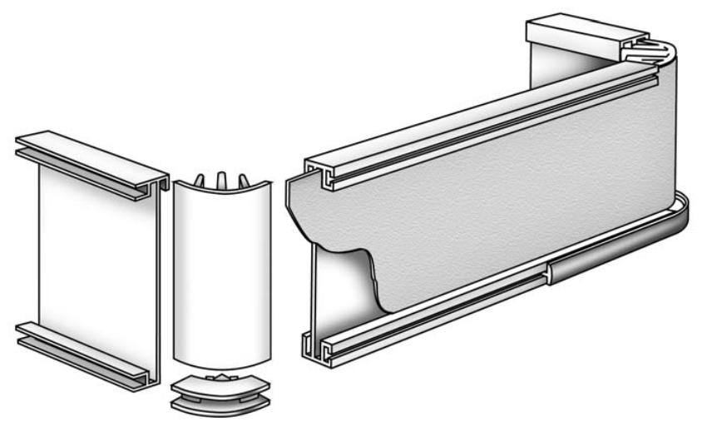

D
C

B

A

A. Executive Valance 2"
B. Executive or Tuscany Trim
C. Corner w/Top & Bottom Cap
D. Vinyl Insert

A

Double Slat Valance
Double Slat Valance
with Hidden Clip

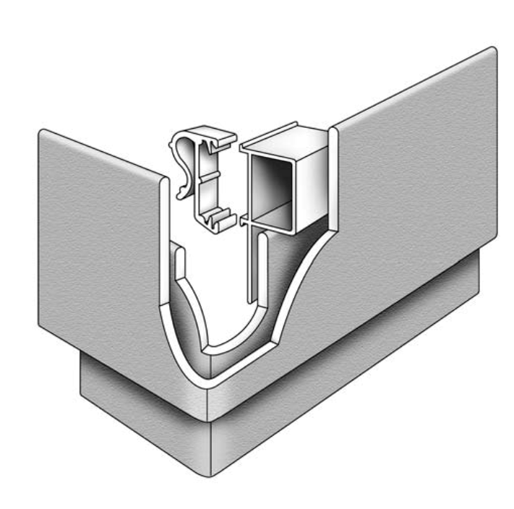
B
A
C
Double Slat Valance with Wraparound Clip

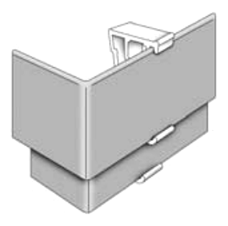
F

C

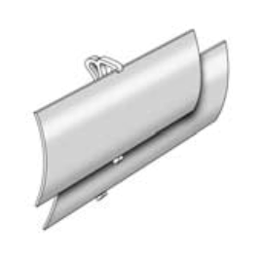
E

A. Hidden Clip
B. Hidden Hanger
C. Fauxwood Slat
D. Vinyl Insert
E. Curved Vinyl Clip
F. Wraparound Clip

Double Slat Valance
With Curved Vinyl Clip
D

Valance Components

- ITEM # DESCRIPTION PCS/CT

VC-ET301 Executive Trim, Gold 301 500
VC-ET303 Executive Trim, Chrome 303 100

VC-ET302 Executive Trim, Dark Walnut 302 100
VC-ET304 Executive Trim, Light Oak 304 100
VC-ET307 Executive Trim, White 307 100
VC-ET630 Executive Trim, Silk 630 100
VC-ET641 Executive Trim, Denim 641 100
VC-ET655 Executive Trim, Sage 655 100
VC-ET672 Executive Trim, Blush 672 100
VC-ET684 Executive Trim, Black Satin 684 100
VC-ET688 Executive Trim, Lilac 688 100

VC-TT622 Tuscany Trim, Pewter 622 100

VC-TT654 Tuscany Trim, Emerald 654 100
VC-TT671 Tuscany Trim, Muscadet 671 100
VC-TT644 Tuscany Trim, Steel Blue 644 100
VC-TT635 Tuscany Trim, Cocoa Silk 635 100
VC-TT670 Tuscany Trim, Pearl Rose 670 100
VC-TT638 Tuscany Trim, Golden Cream 638 100
VC-TT687 Tuscany Trim, Aubergine 687 100
VC-TT610 Tuscany Trim, Pearl White 610 100

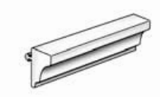
VC-RTS Renaissance Trim, Paintable-Stainable 14
VC-RTI Renaissance Trim, Ivory 14
VC-RTW Renaissance Trim, White 14

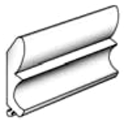
VC-CTS Colonial Trim, Paintable-Stainable 6
VC-CTI Colonial Trim, Ivory 6
VC-CTW Colonial Trim, White 6

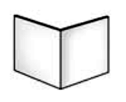
VC-ICS Inside Corner Support, White 84" 10

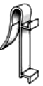

VC-EVB Executive Valance Bracket, White 11

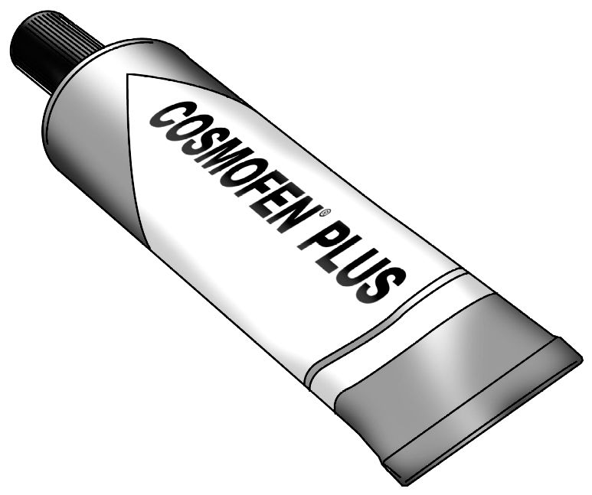
VC-GLUE PVC Instant Dry Gel 1

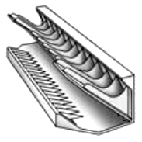

VC-CG 45 Degree Cutting Guide 1

Valance Components

ITEM # DESCRIPTION PCS/CT
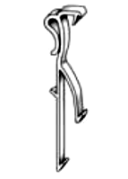

HV-CVC Curved Vinyl Valance Clip 1000

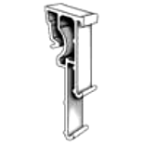

HV-WC Wraparound Clip, Clear 1000

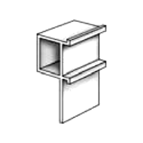

HV-HH1 Hidden Hanger (Part 1 of 2) 100

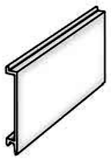

HV-VC1 Hidden Clip, Plastic w/Double Sided Tape (Part 1 of 2) 1000

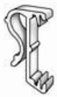

HV-HC Hidden Clip (Part 2 of 2) 1000

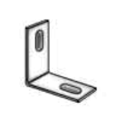

HV-LS3 4 Valance Corner, L-Sleeve, ¾” 500
HV-LS12 Valance Corner, L-Sleeve, ½” 500

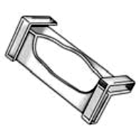

HV-FVC FauxWood Corner Valance Clip 500

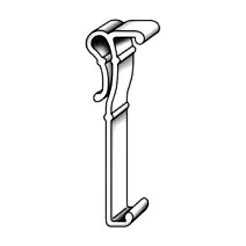

HV-SO2 Valance Clip, 2 ½” Snap On, Opaque 500
HV-SO3 Valance Clip, 3 ¼” Snap On, Opaque 500

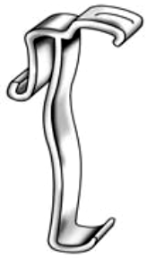

HV-SA2 Valance Clip, 2 ½” Snap Around, Clear 500
HV-SA3 Valance Clip, 3 ¼” Snap Around, Clear 500



HV-HVC2 Hidden Channel Valance Clip, 2 ½” Plastic 2000
HV-HVC3 Hidden Channel Valance Clip, 3 ¼” Plastic 500

High Profile Headrail System
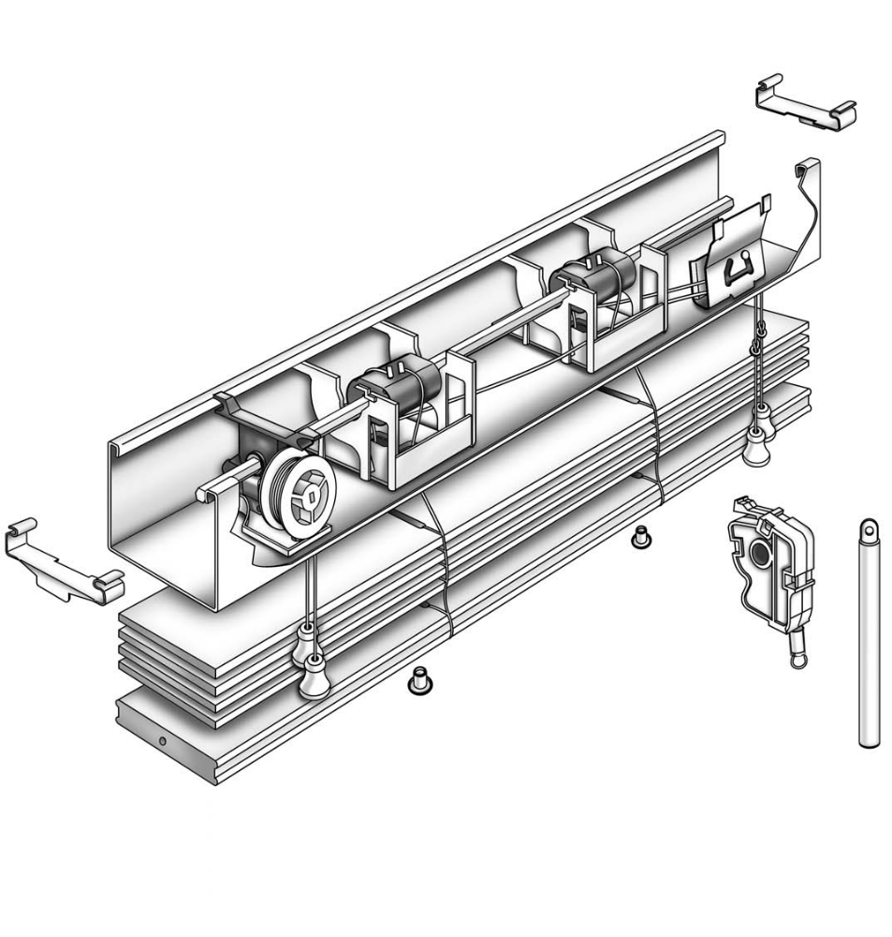

A
P
B

D
C
O

E
N

A. Channel
B. Tilt Rod
C. Tape Drum
D. Tape Drum Support
E. Cord Tilter
F. End Stiffener
G. Tassel
H. Cord Retainer Button
I. Ladder
J. Routing Cord
K. Optional Wand Tilter
L. Tilt Wand
M. 2" Standard Bottom Rail
N. 2" Slat
O. Cord Stop
P. Cord Lock

J

F
I
K

H
G
L
M

SPECIFICATIONS

Channel: Baked on enamel to match slat color. Roll formed steel - 2" wide x 2" high.

Valance: Accepts valance clips for all valances.

Bottom Rail: Fauxwood or steel, closed channel bottom rails available in coordinating colors. Components compatible
with all bottom rails.

Controls: Cord Lift: Universal cord lock to keep blind in open position. Tape drum and drum supports for even ladder
control. 44mm ladders in coordinating colors or 1 1/2" cotton twill tapes in accent colors.
Cord Tilt: Square, steel tilt rod. 1.8 mm or 2.2 mm cords in coordinating colors.
Wand Tilt: 180 degree turn for open and closed blinds in either direction.

Mounting Hardware: Box brackets for inside or outside mounting, available in coordinating colors. Center supports
available in zinc or coordinating colors. Extension brackets and hold down brackets available.

Size Recommendations: Width: minimum 9", maximum 108"
Length: minimum 9", maximum 126"

High Profile Headrail System

ITEM # DESCRIPTION PCS/CT

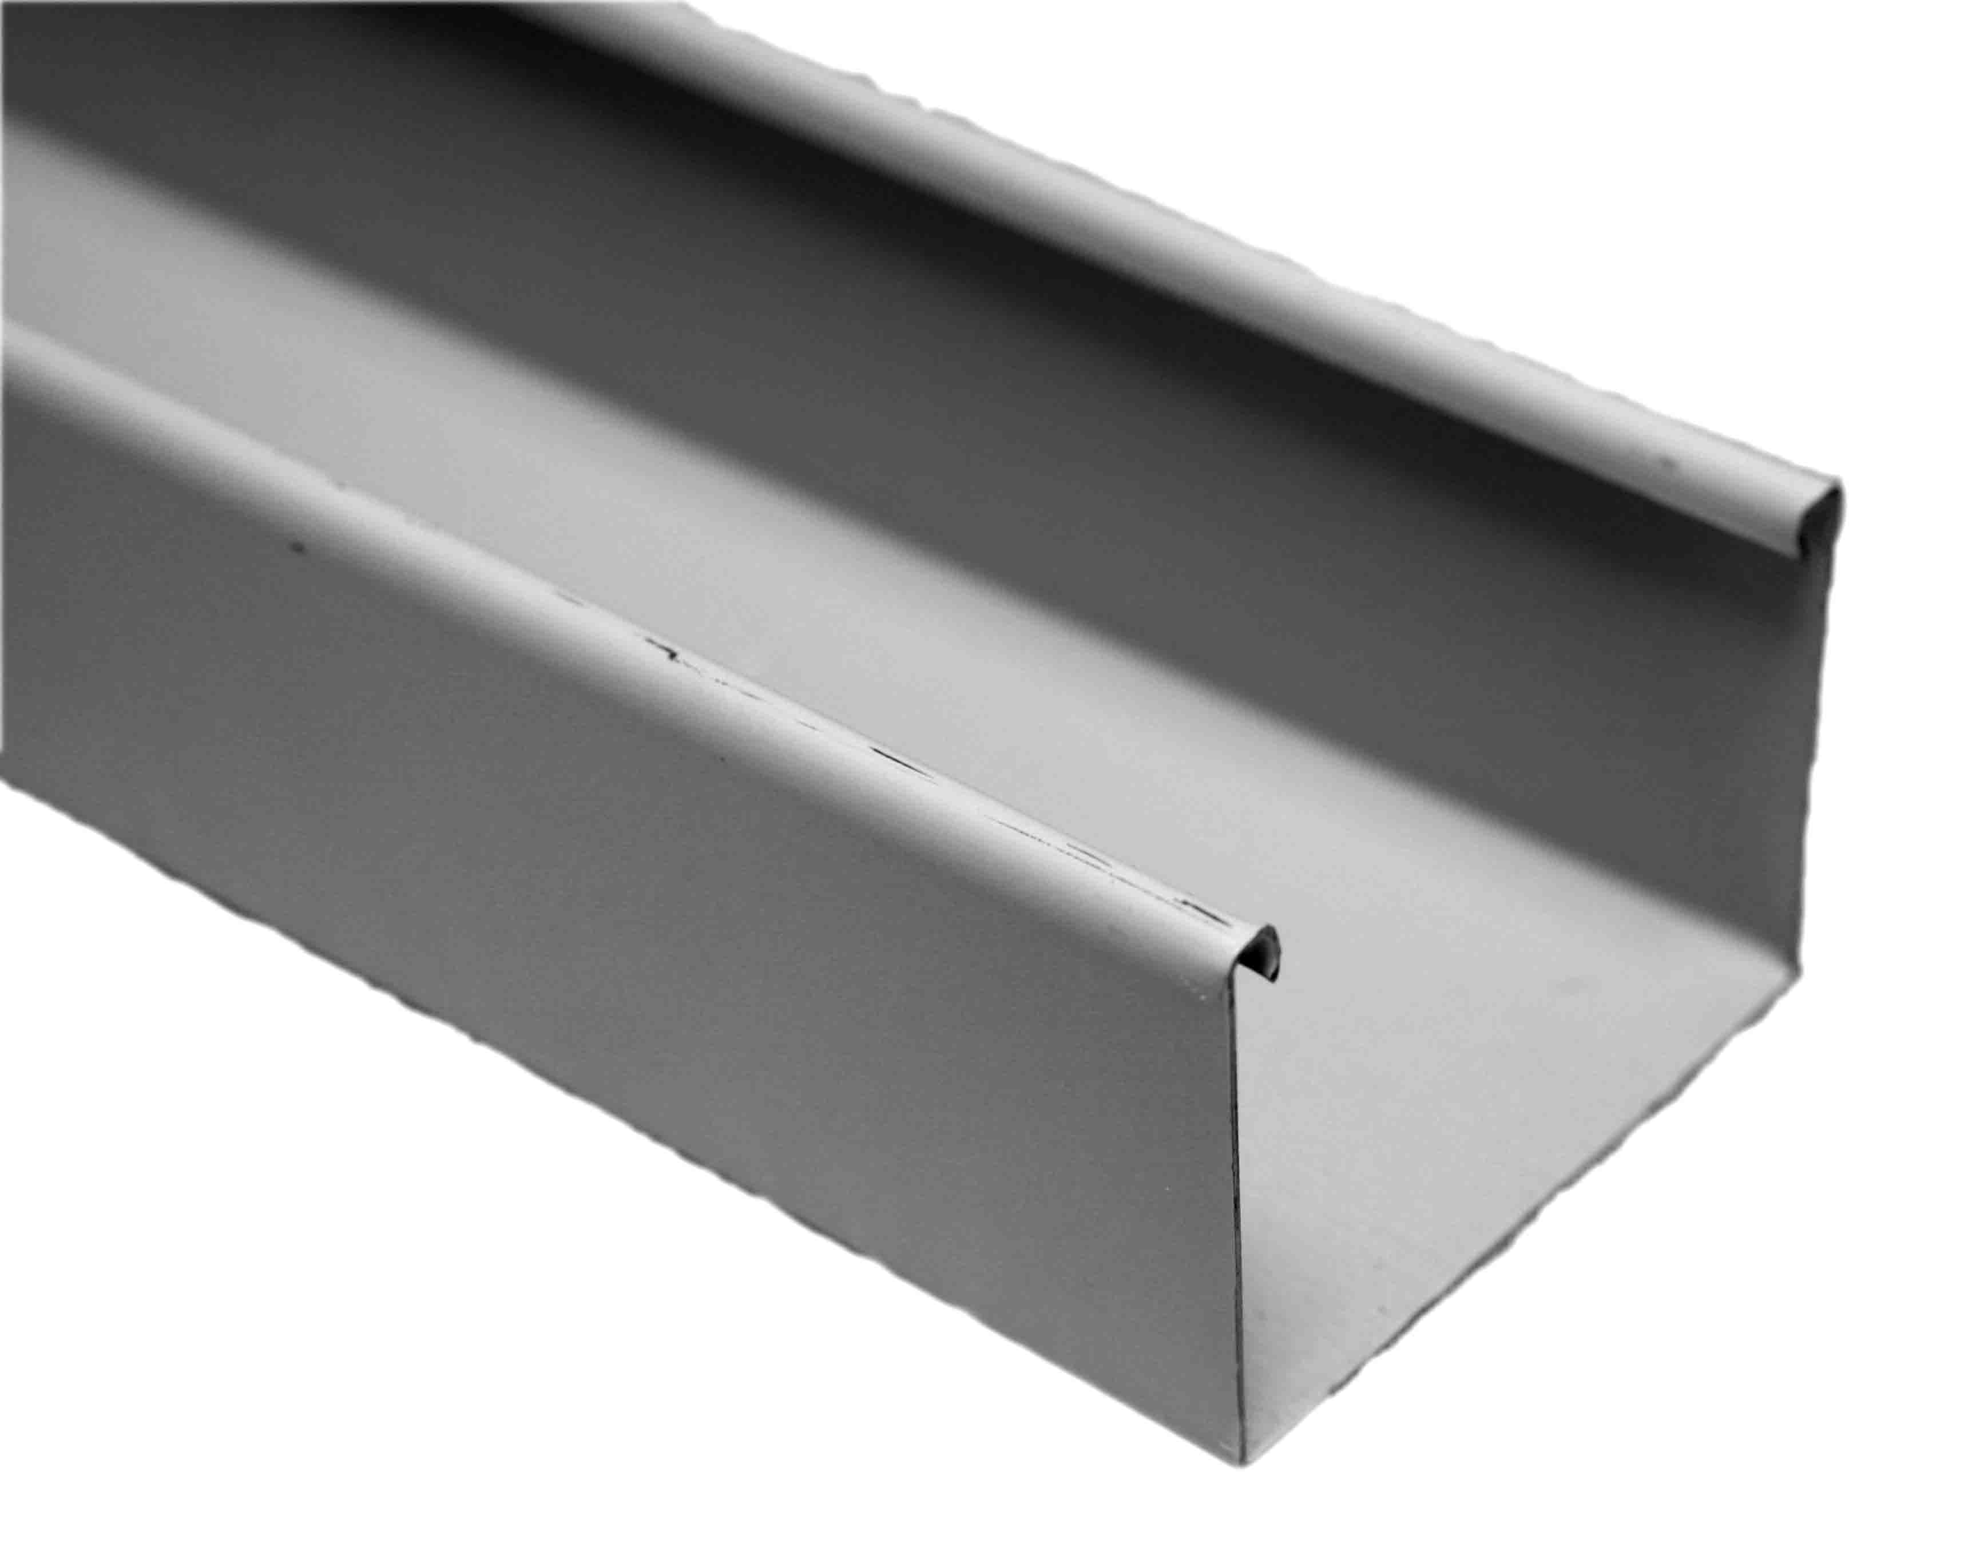
HP-HR112 Channel, 2" x 2” x 16', Alabaster 112 12
HP-HR086 Channel, 2" x 2” x 16', Camel 086 12
HP-HR060 Channel, 2" x 2” x 16', Chocolate 060 12
HP-HR100 Channel, 2" x 2” x 16', Vanilla 100 12 HP-HR005 Channel, 2" x 2” x 16', White Gloss 005 12
HP-HR205 Channel, 2" x 2” x 16', White Satin 205 12

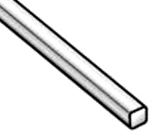

HP-TR Tilt Rod, Steel Hexagonal 16’ 25

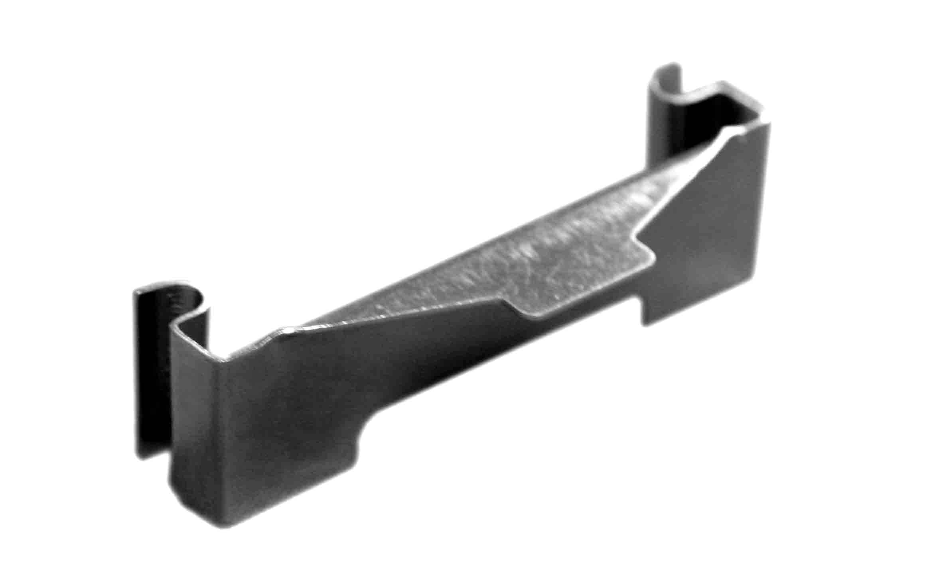

HP-ESR End Stiffener, Regular 500

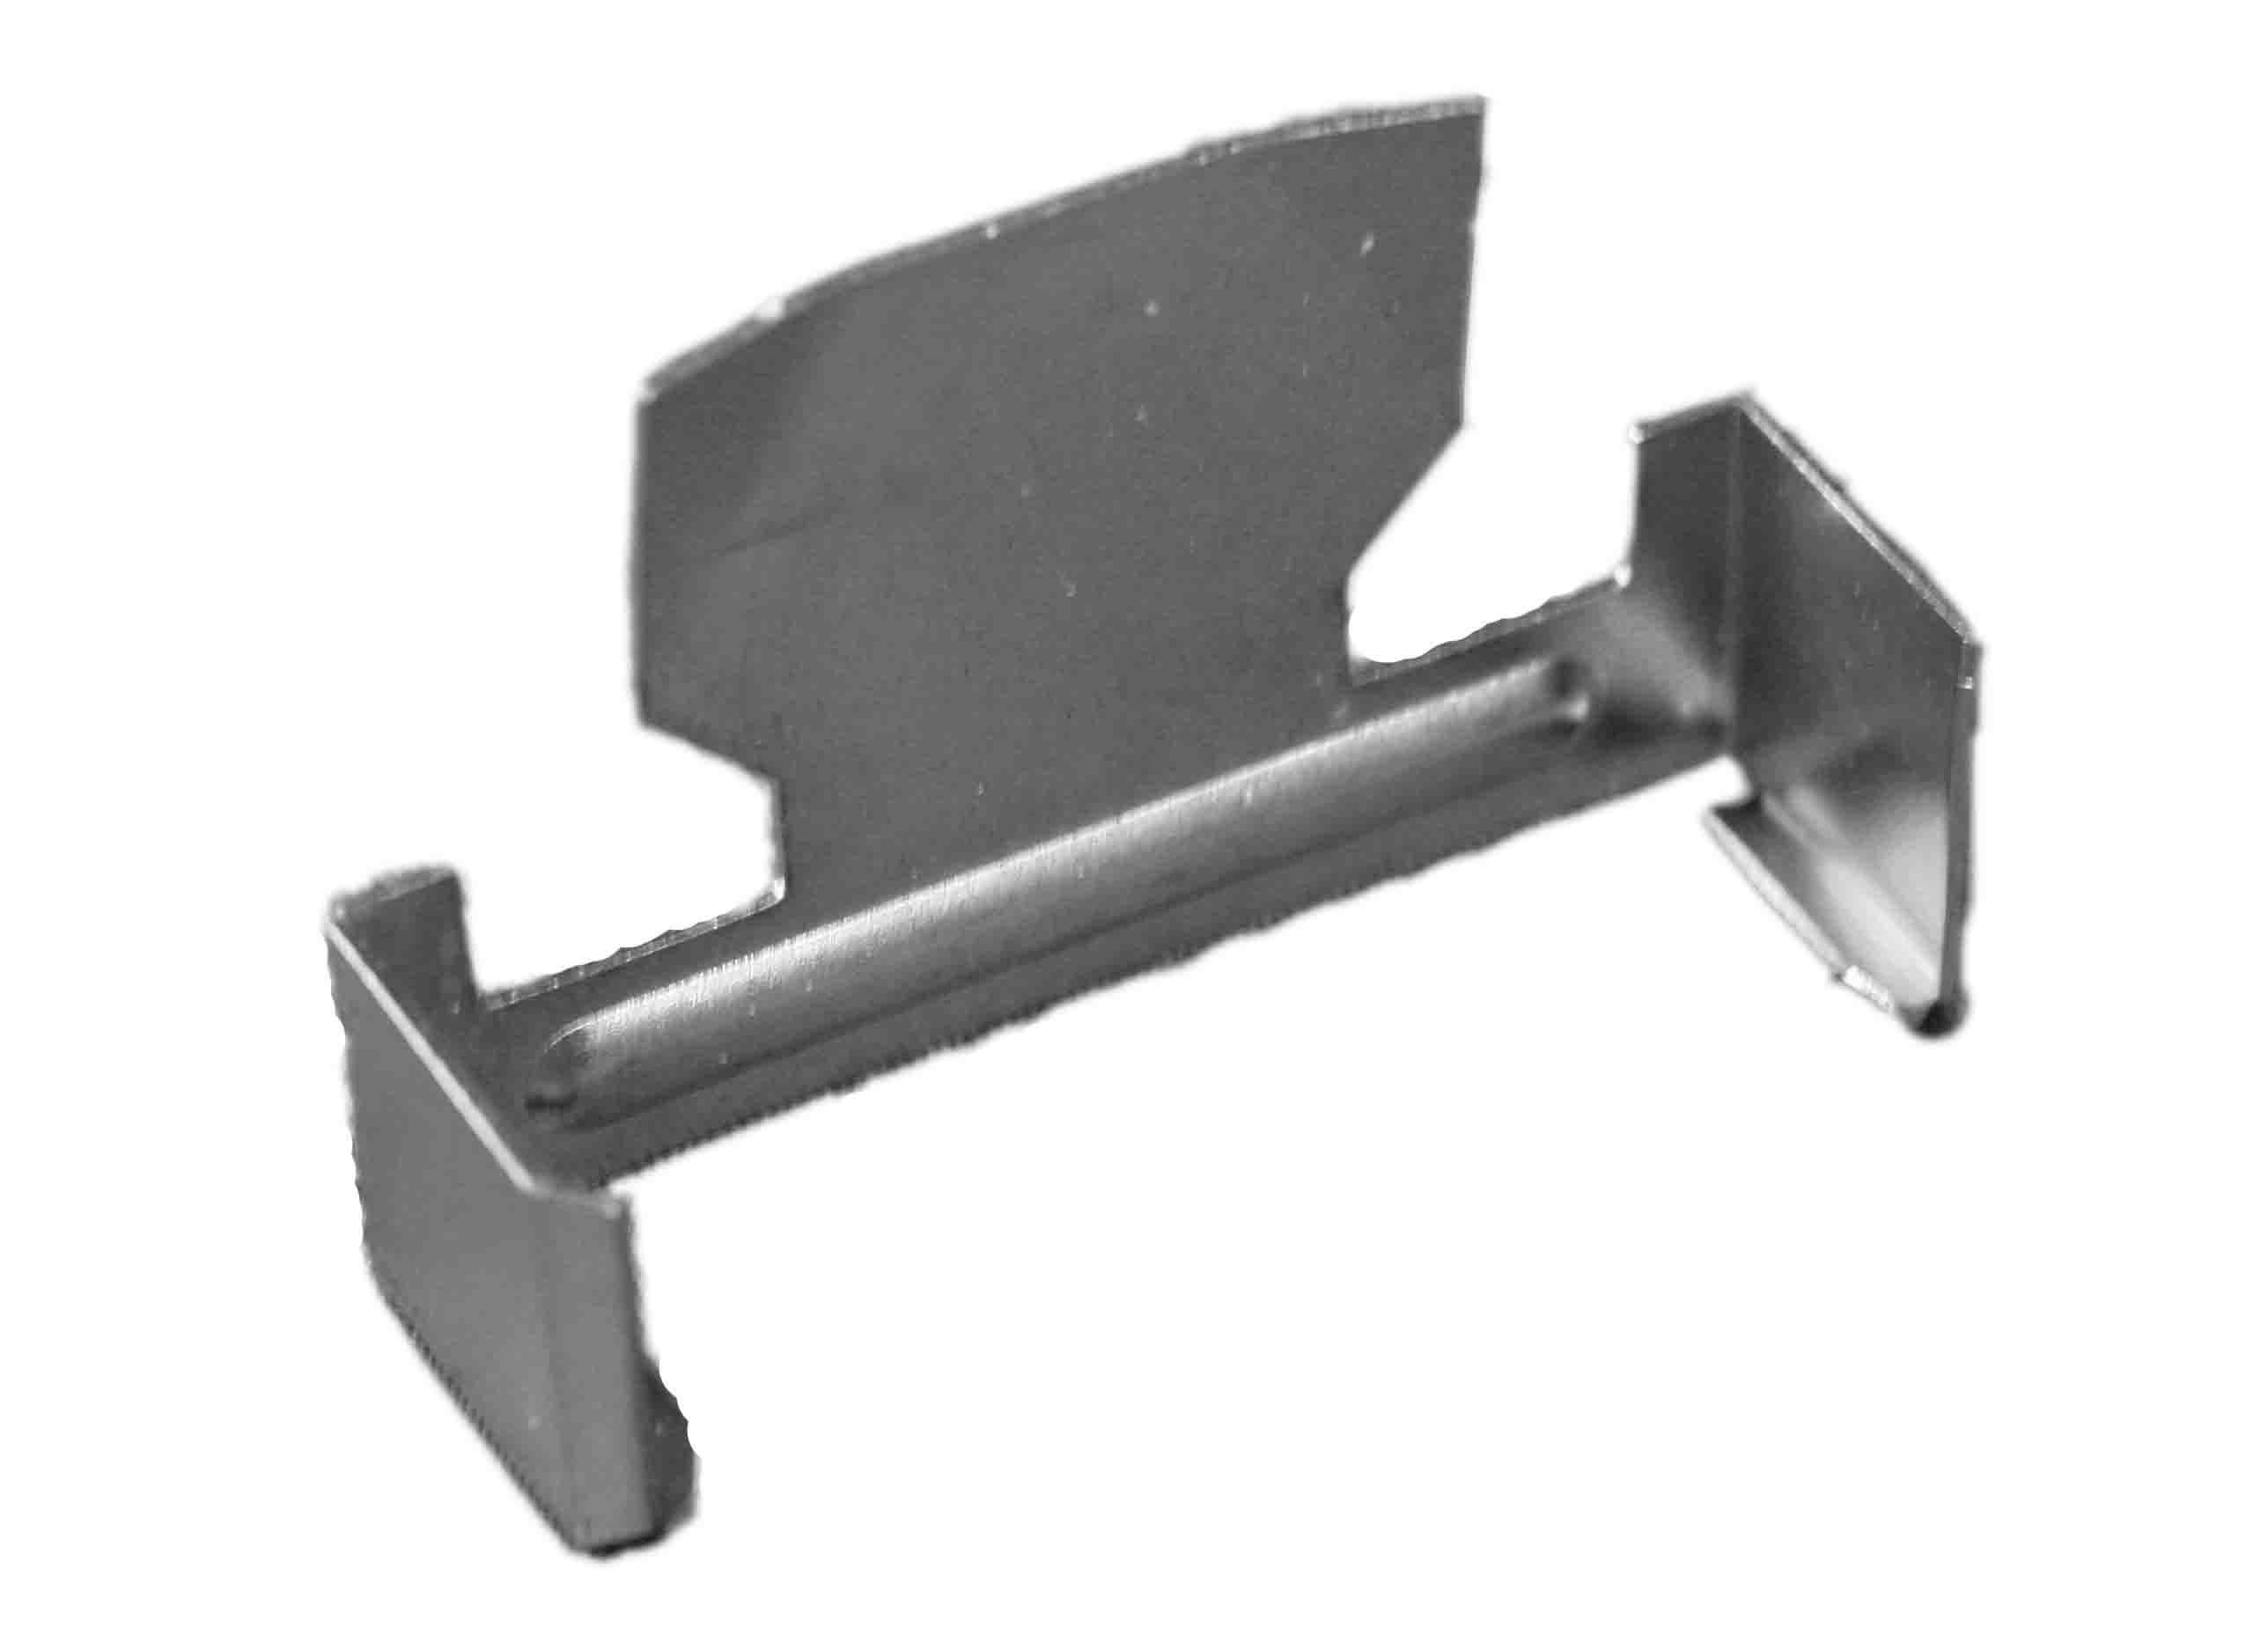

HP-ESHD End Stiffener, Heavy Duty, Zinc Plated 2000

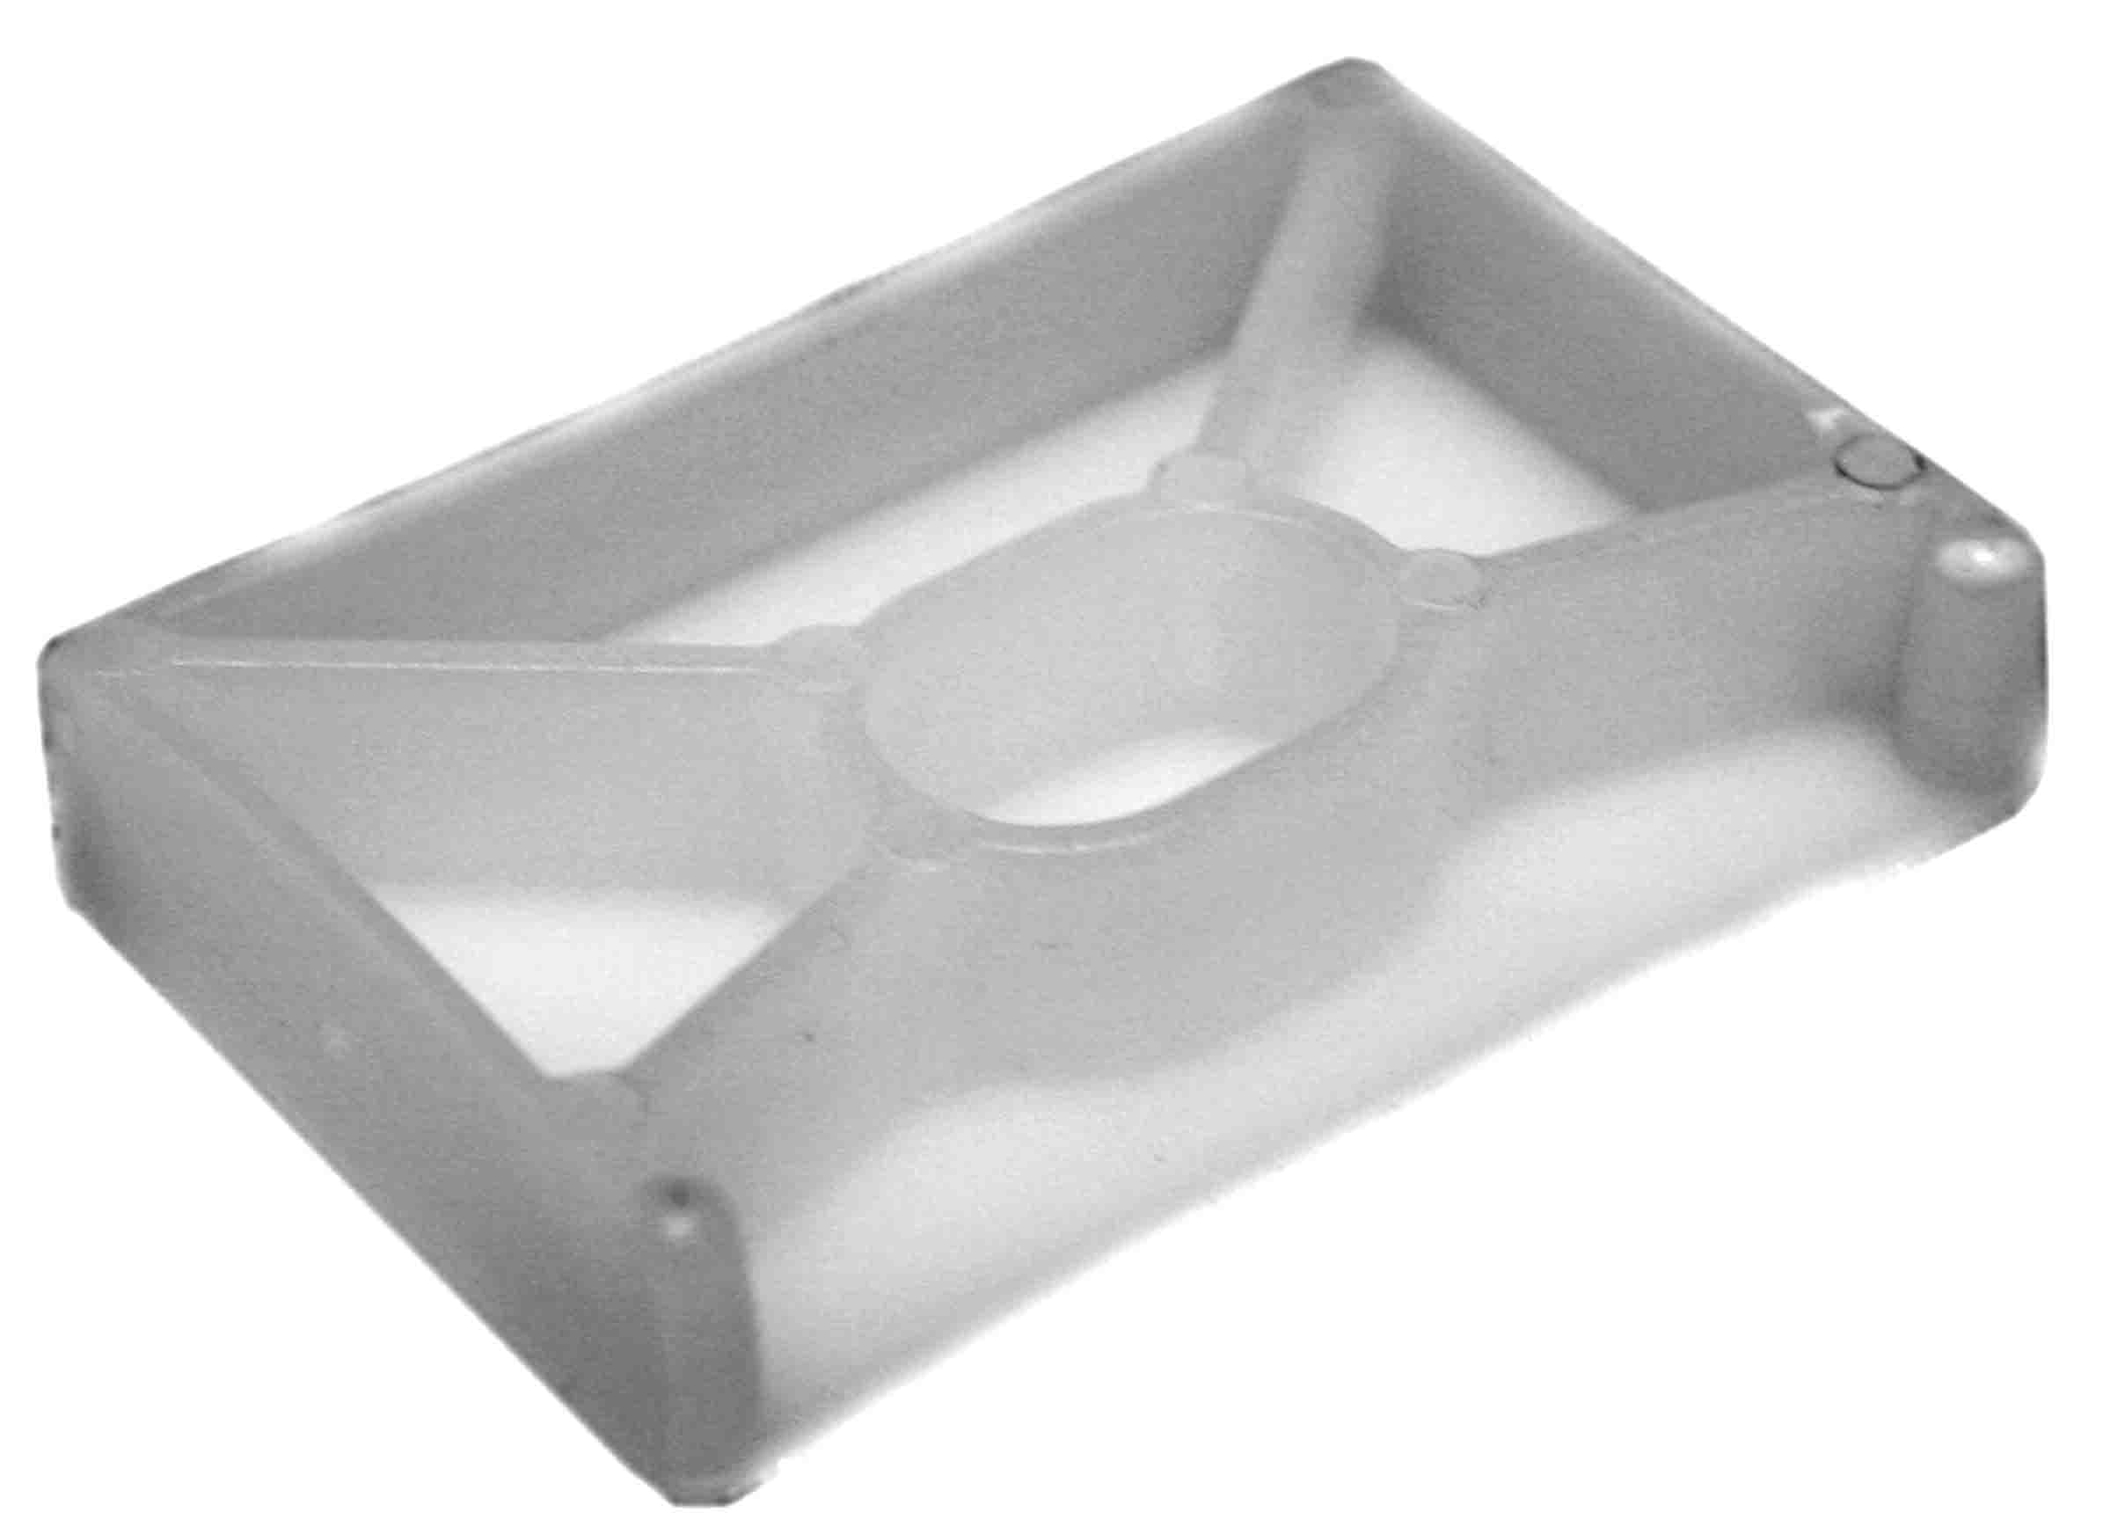

HP-ESP End Stiffener, Plastic, Translucent 1000

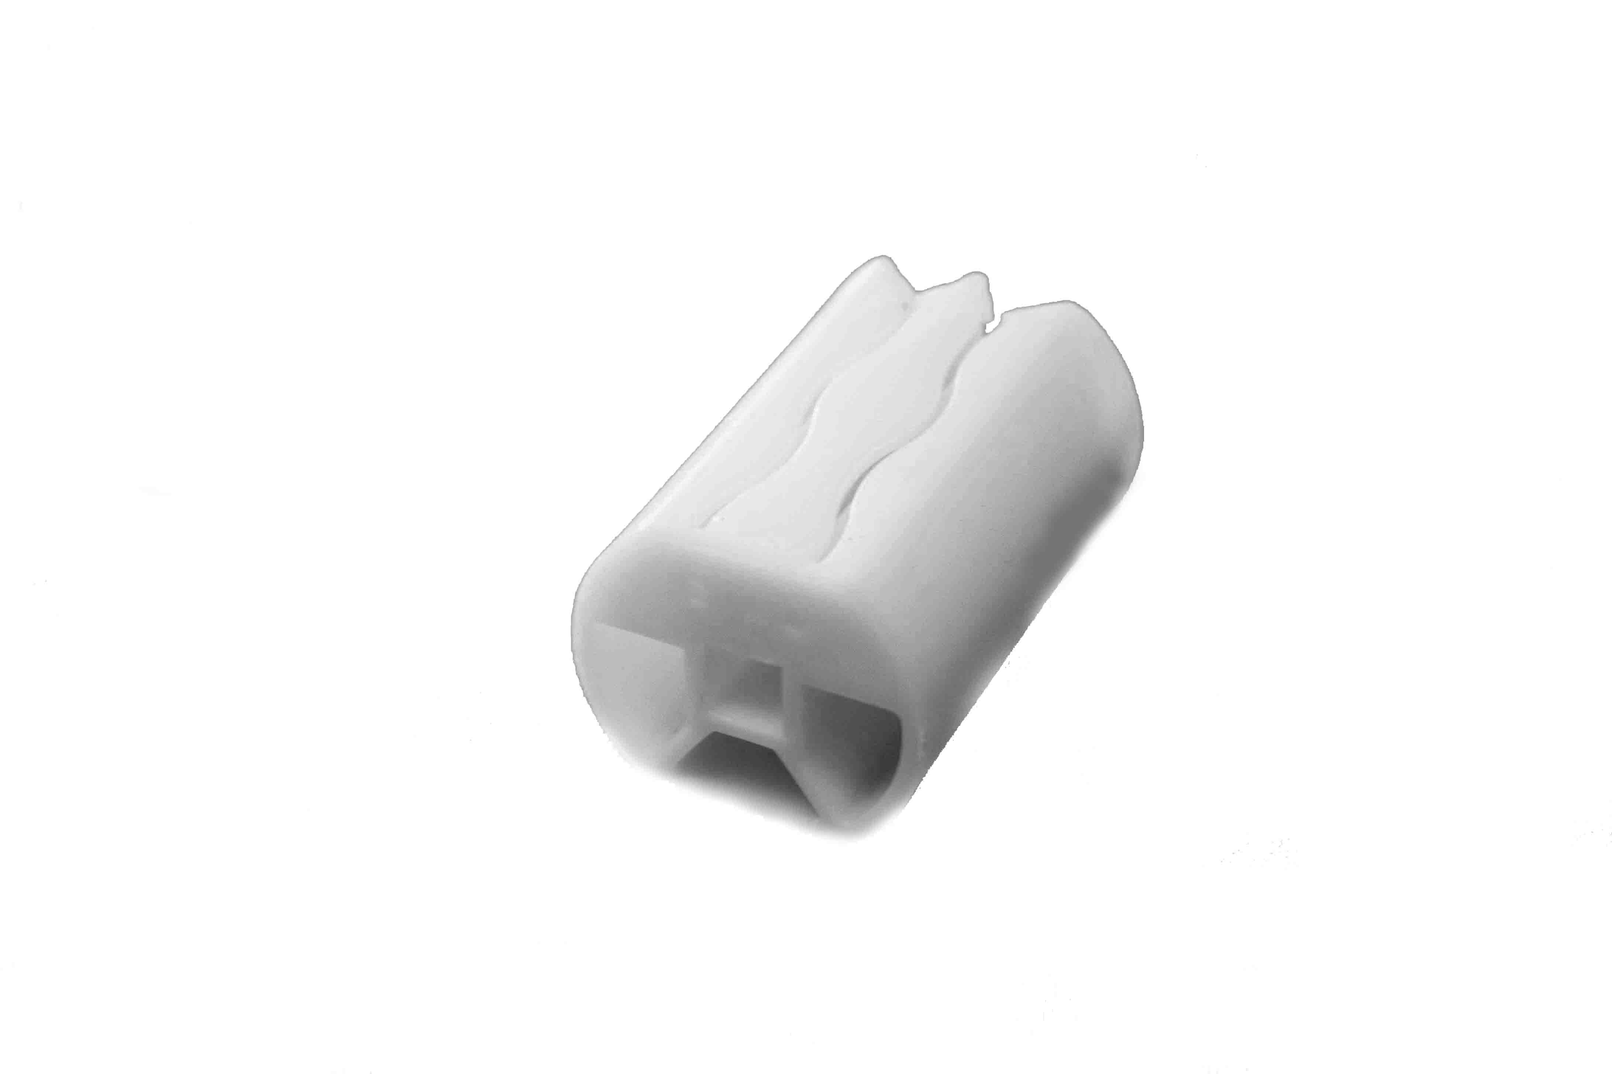

HP-TDU Tape Drum, Universal, Plastic 1000

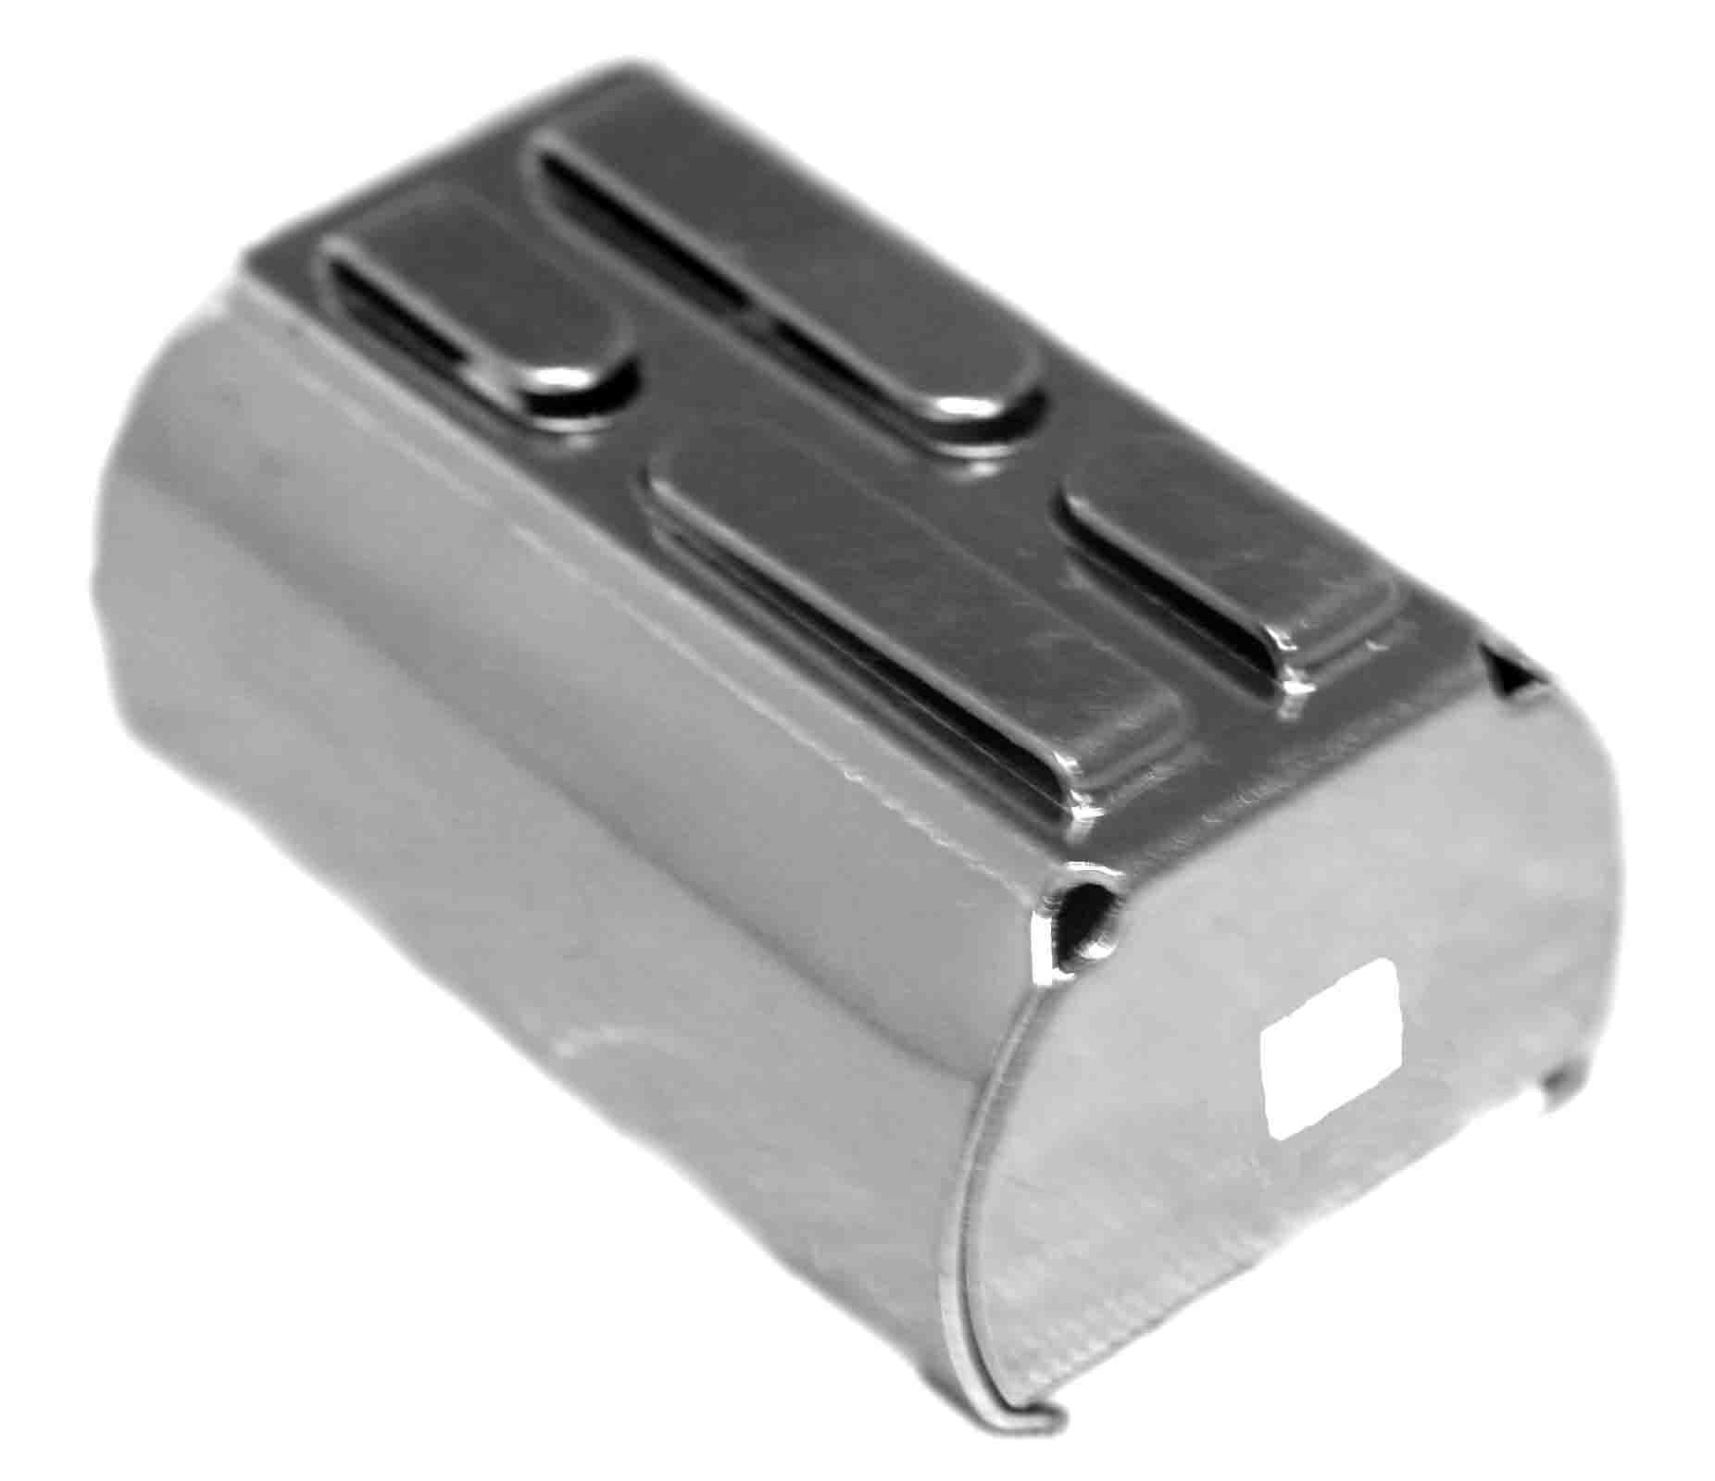

HP-TDT Tape Drum, Metal, Cloth Tape 400

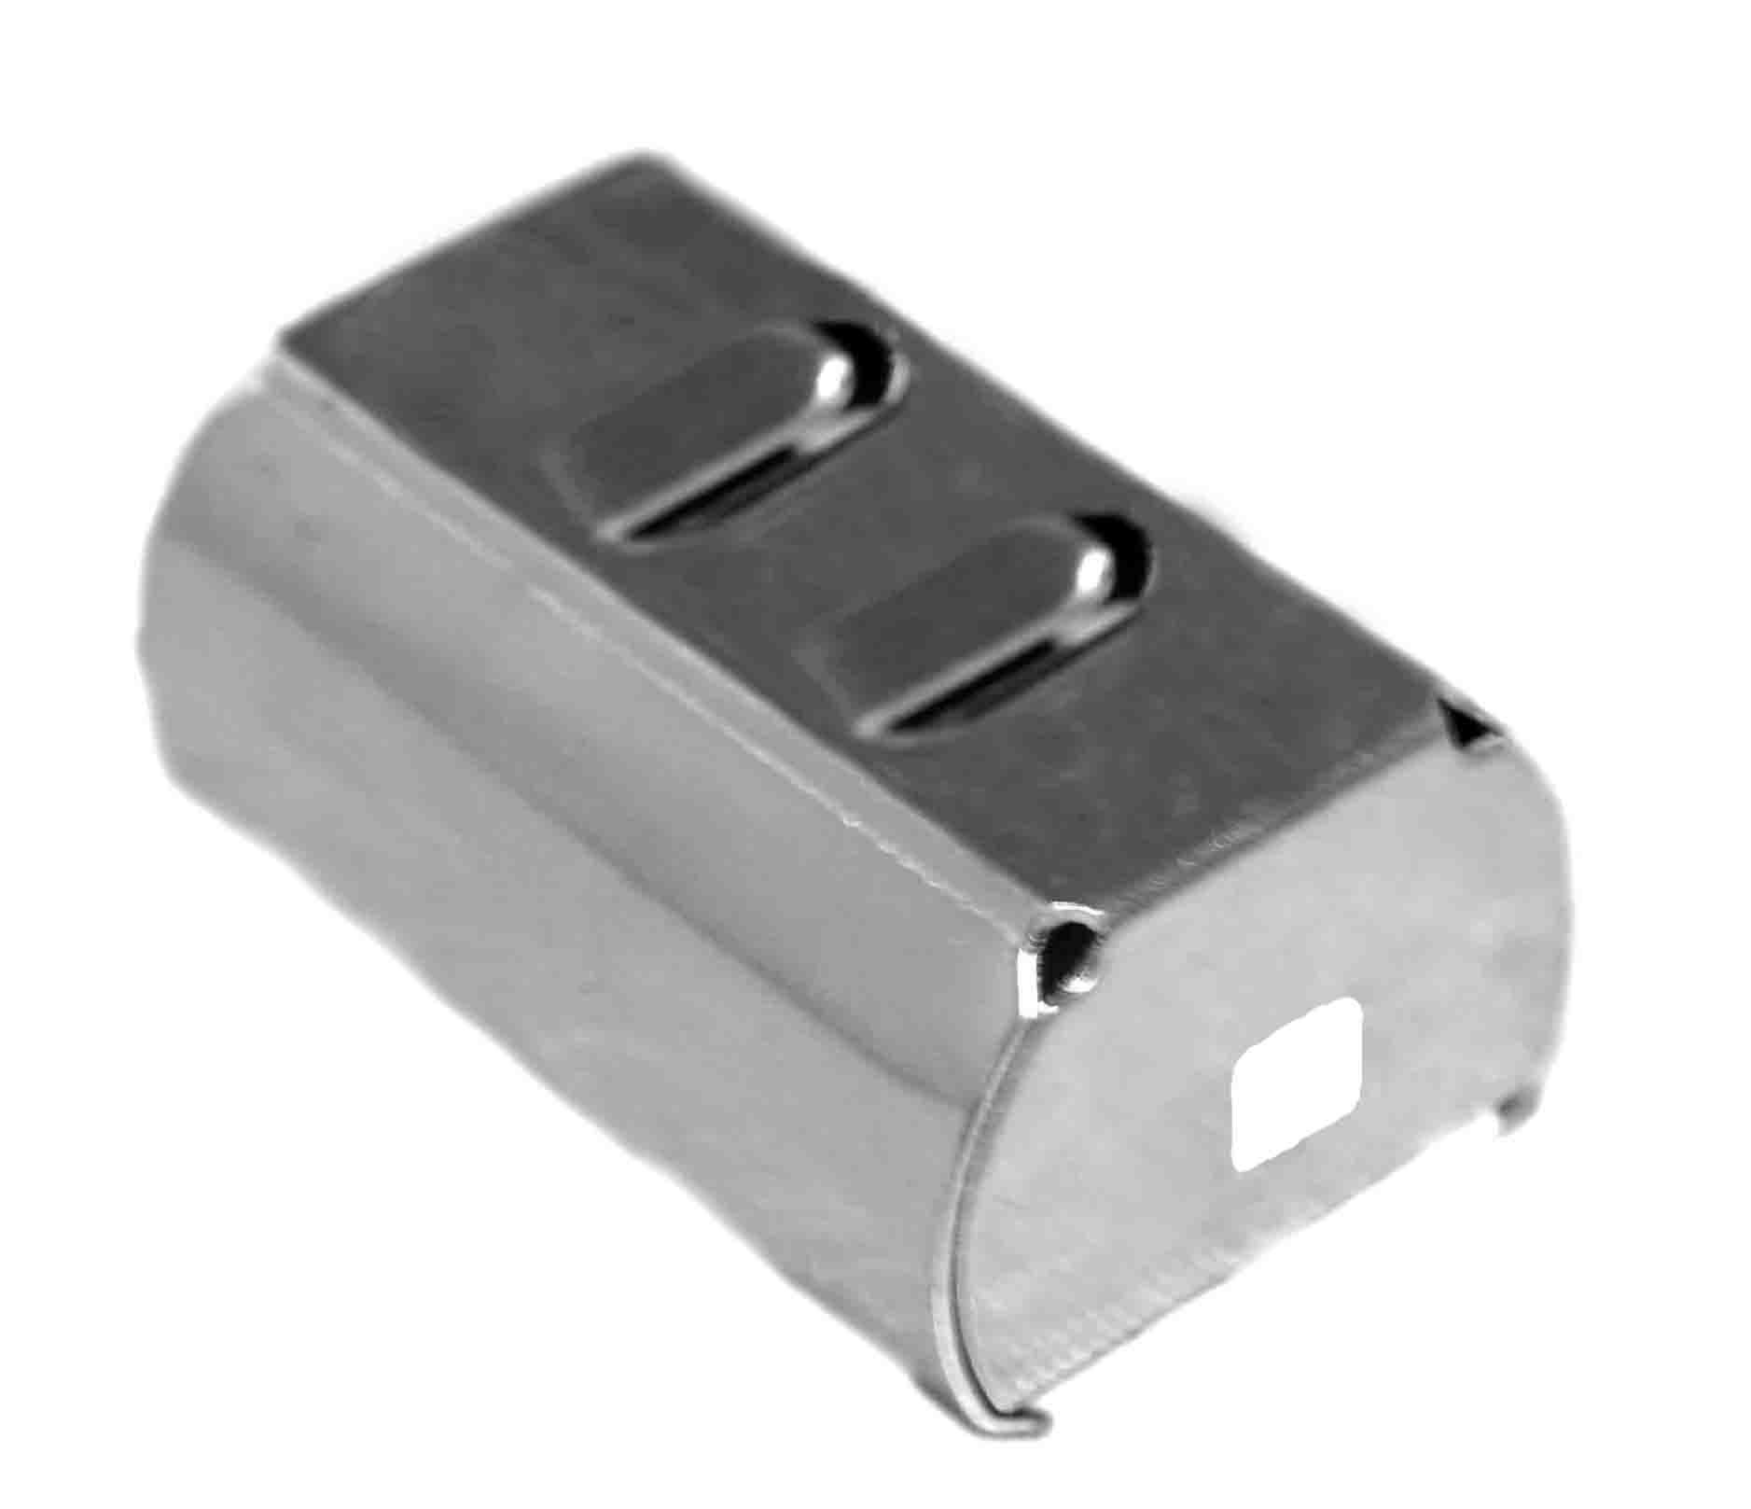

HP-TDF Tape Drum, Metal, Diagonal with Finger 400

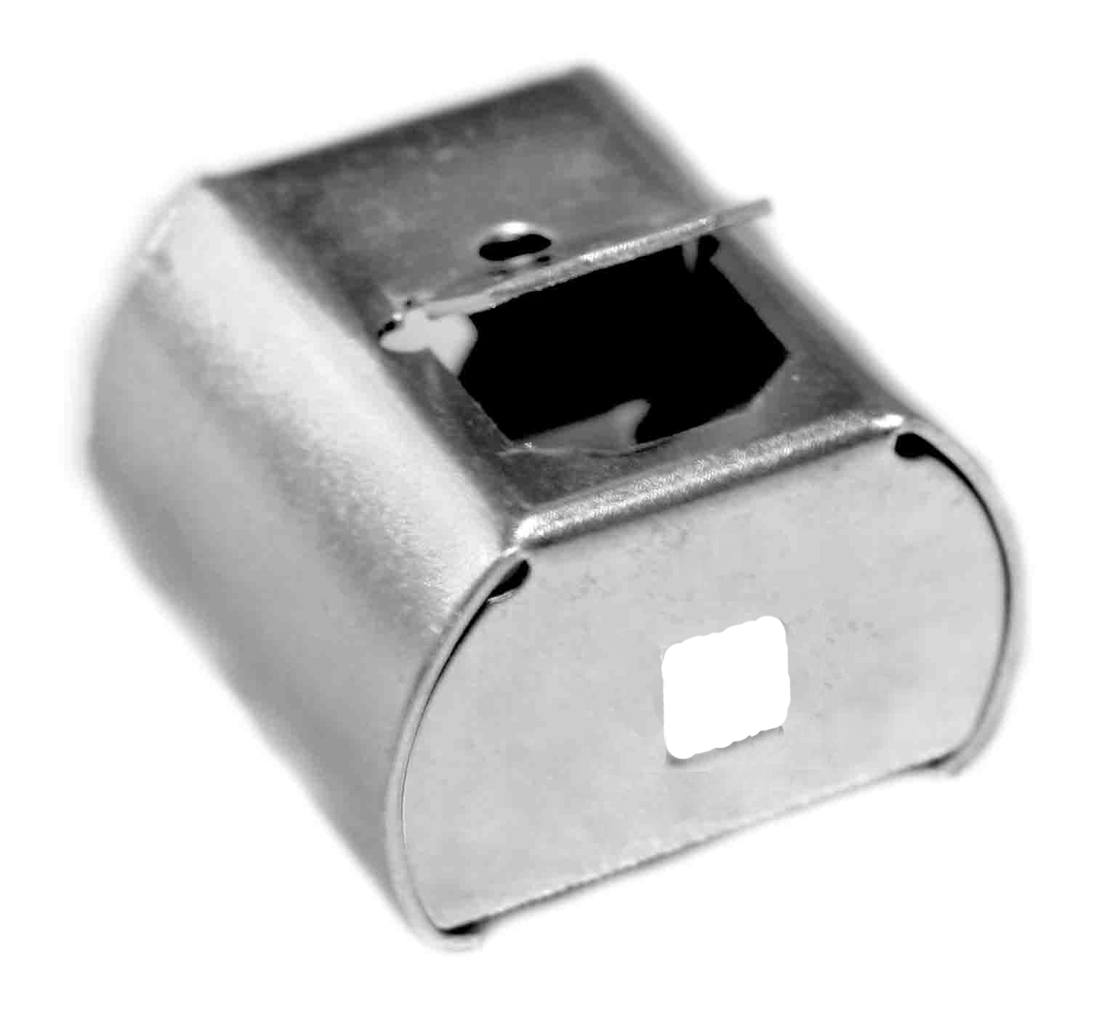

HP-TDD Tape Drum, Metal, D-Door 400

High Profile Headrail System

ITEM # DESCRIPTION PCS/CT
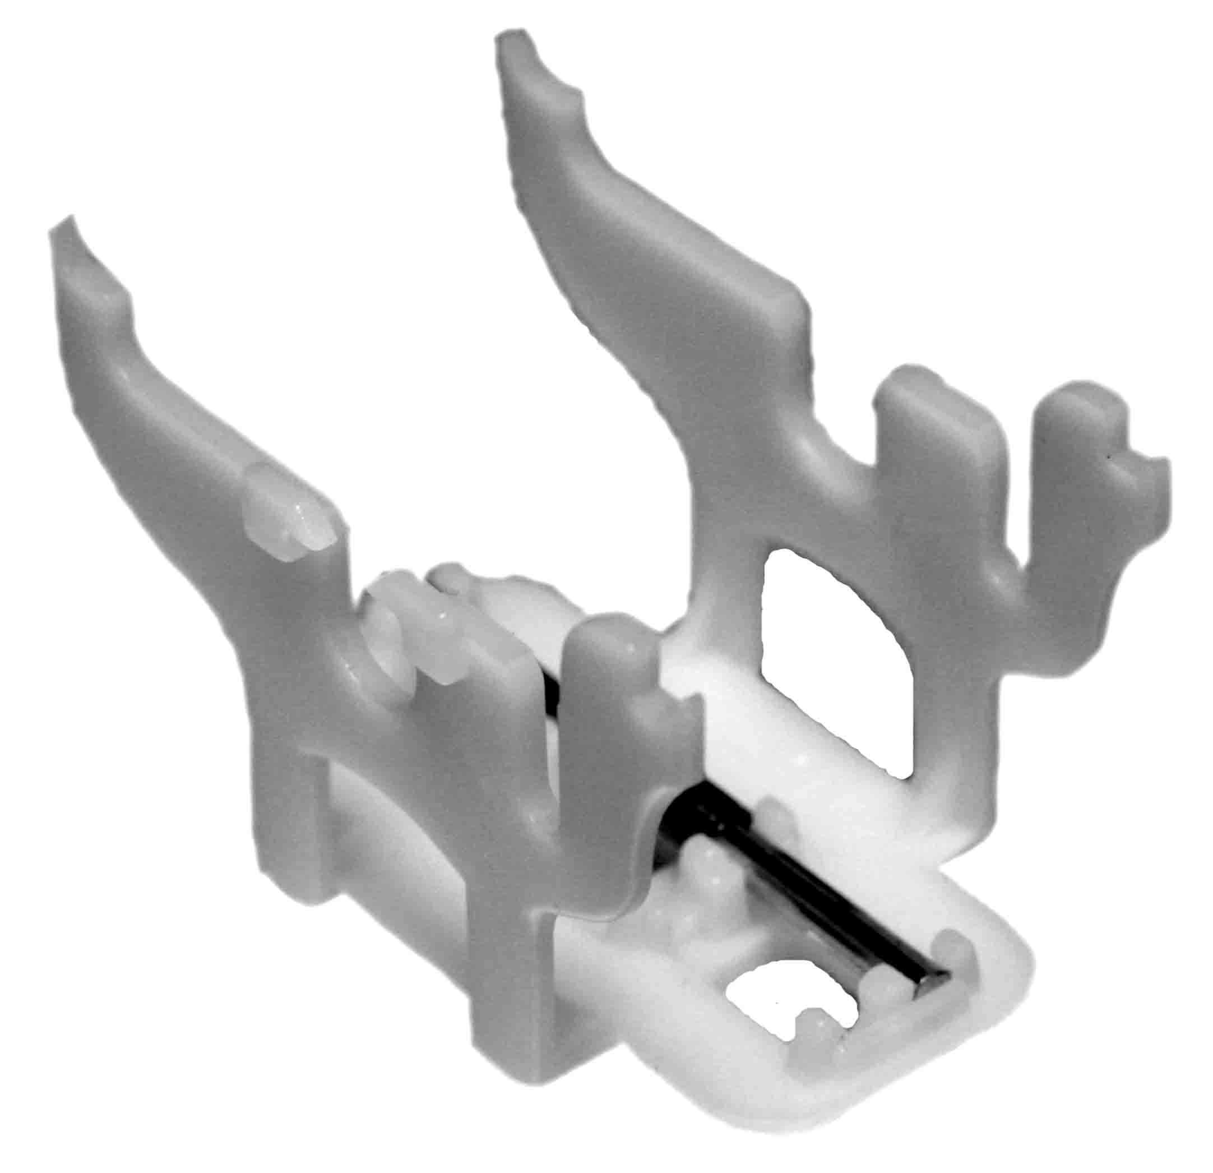

HP-TDSU Tape Drum Support, Universal Ladder/Routeless with Wheel 1000
HP-TDSR Tape Drum Support, Routeless only with Wheel 1000

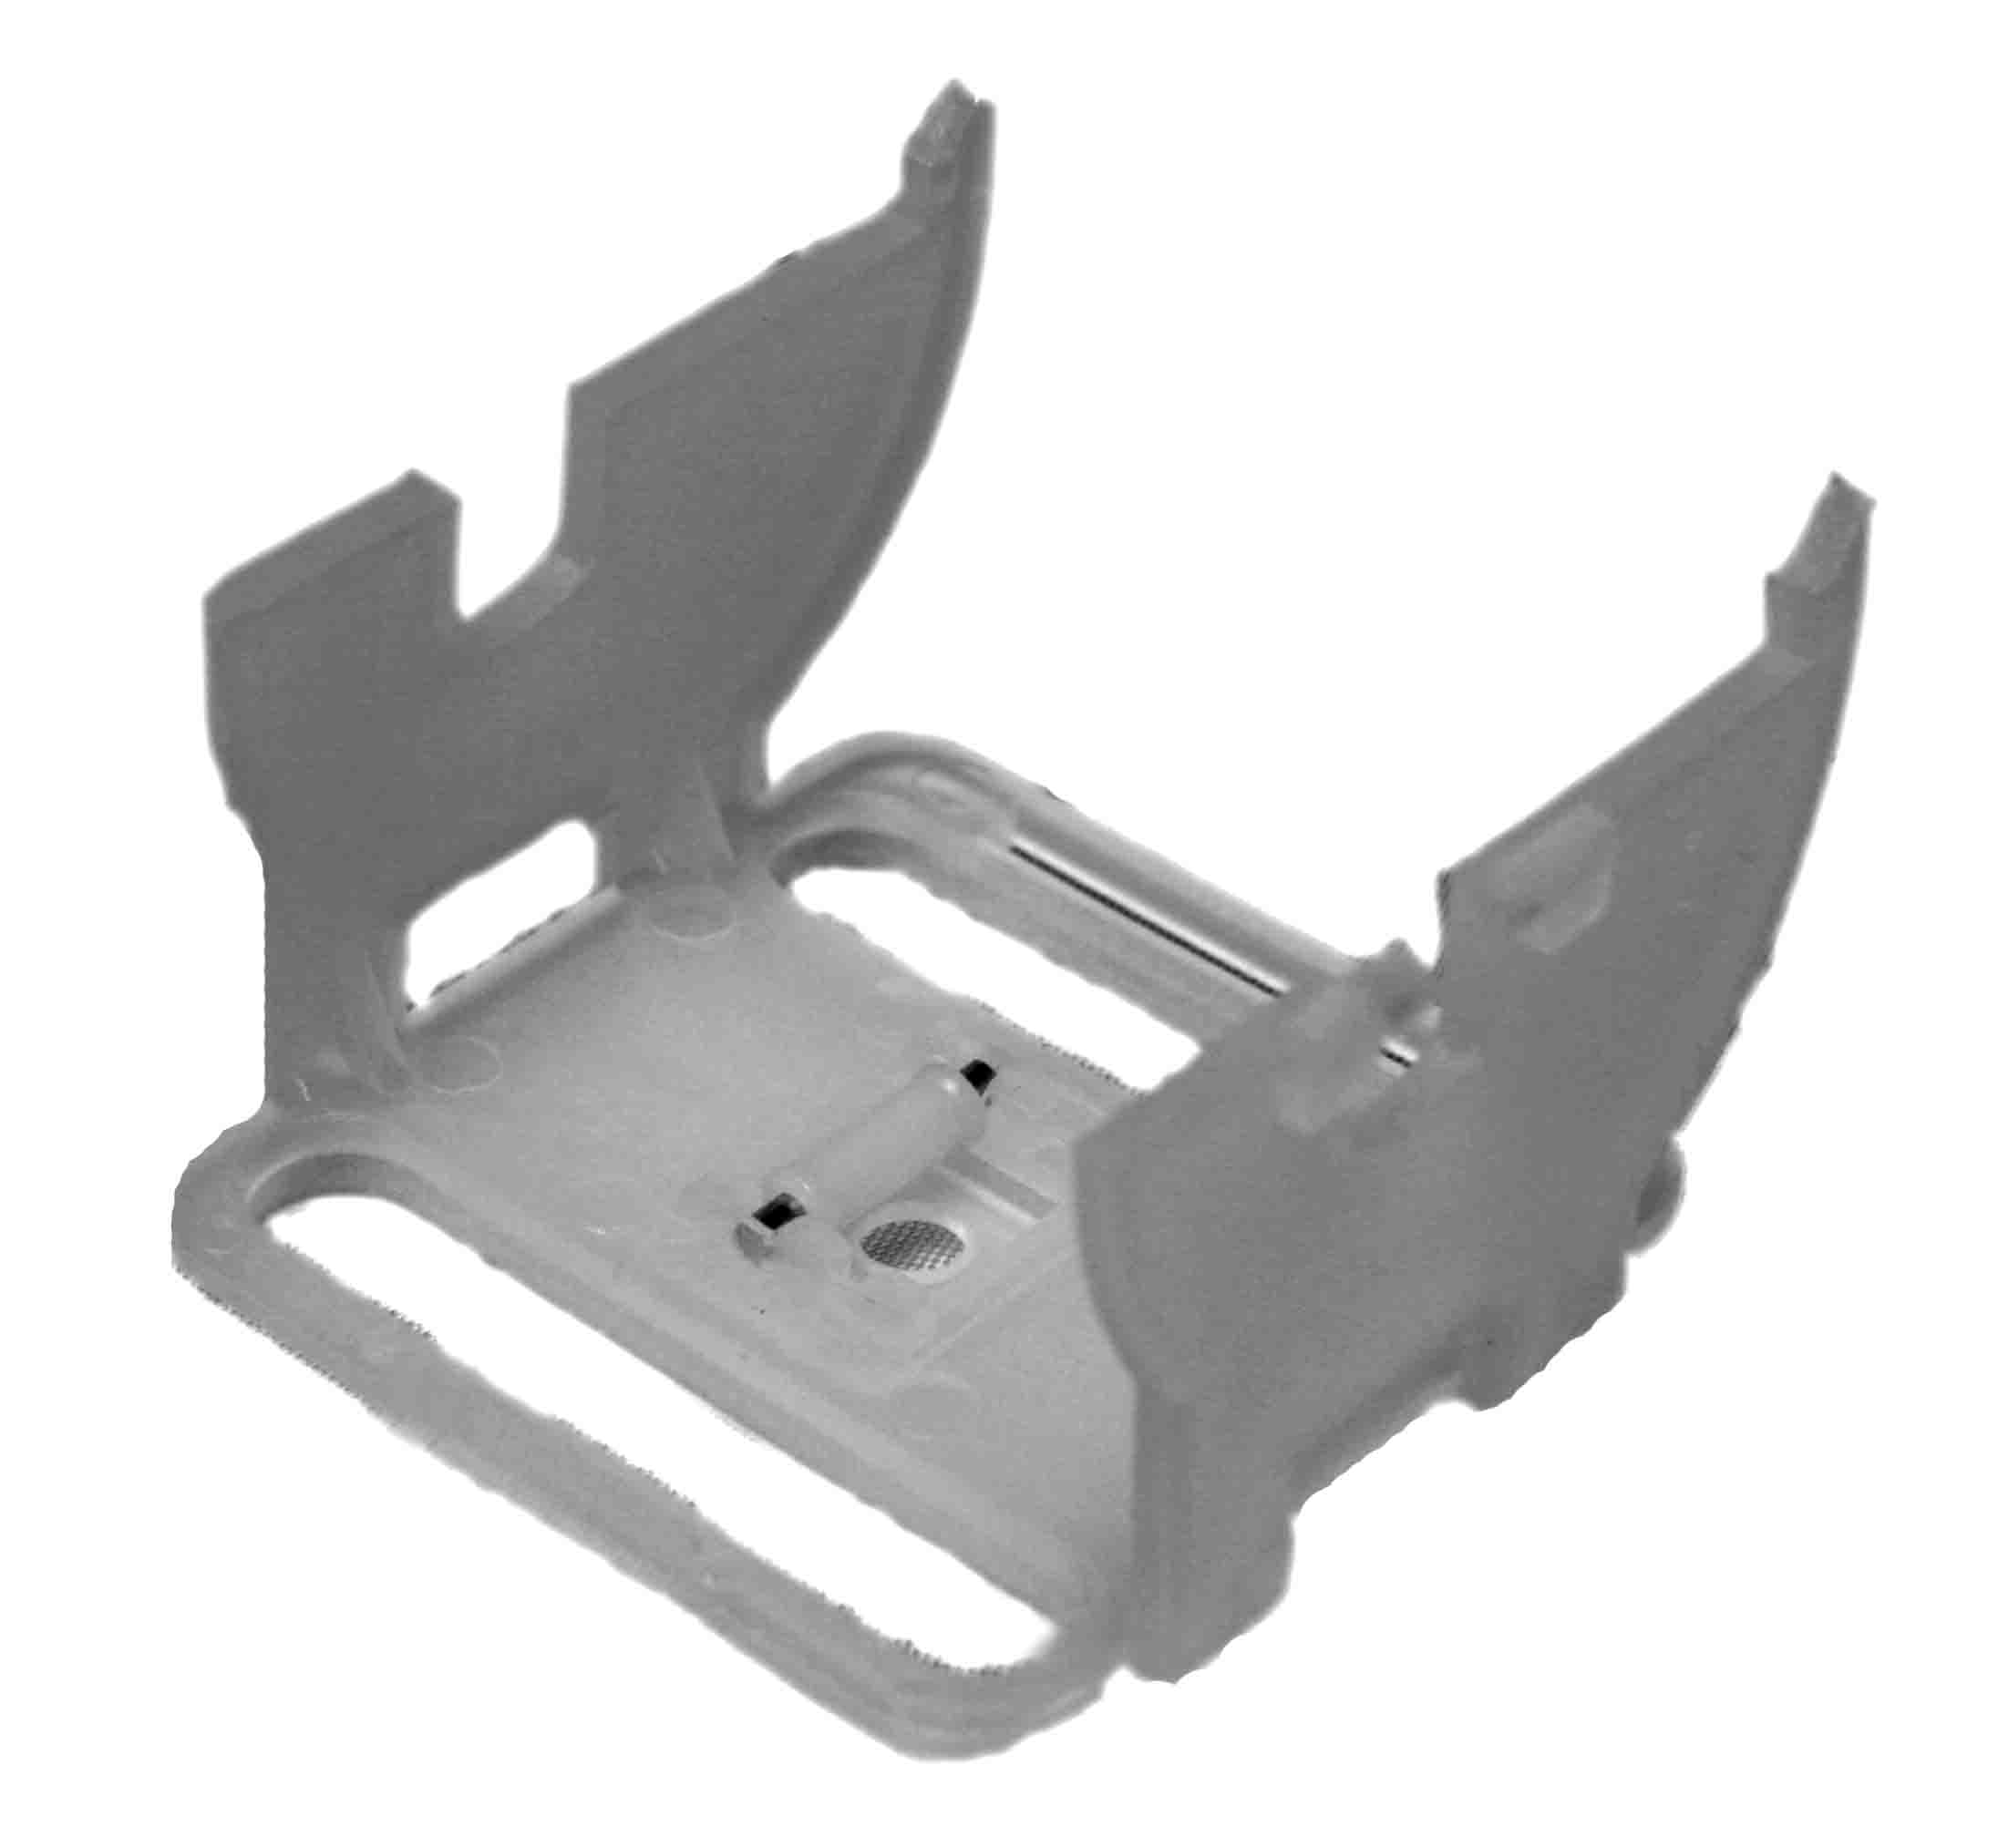

HP-TDST Tape Drum Support, Cloth Tape 1000

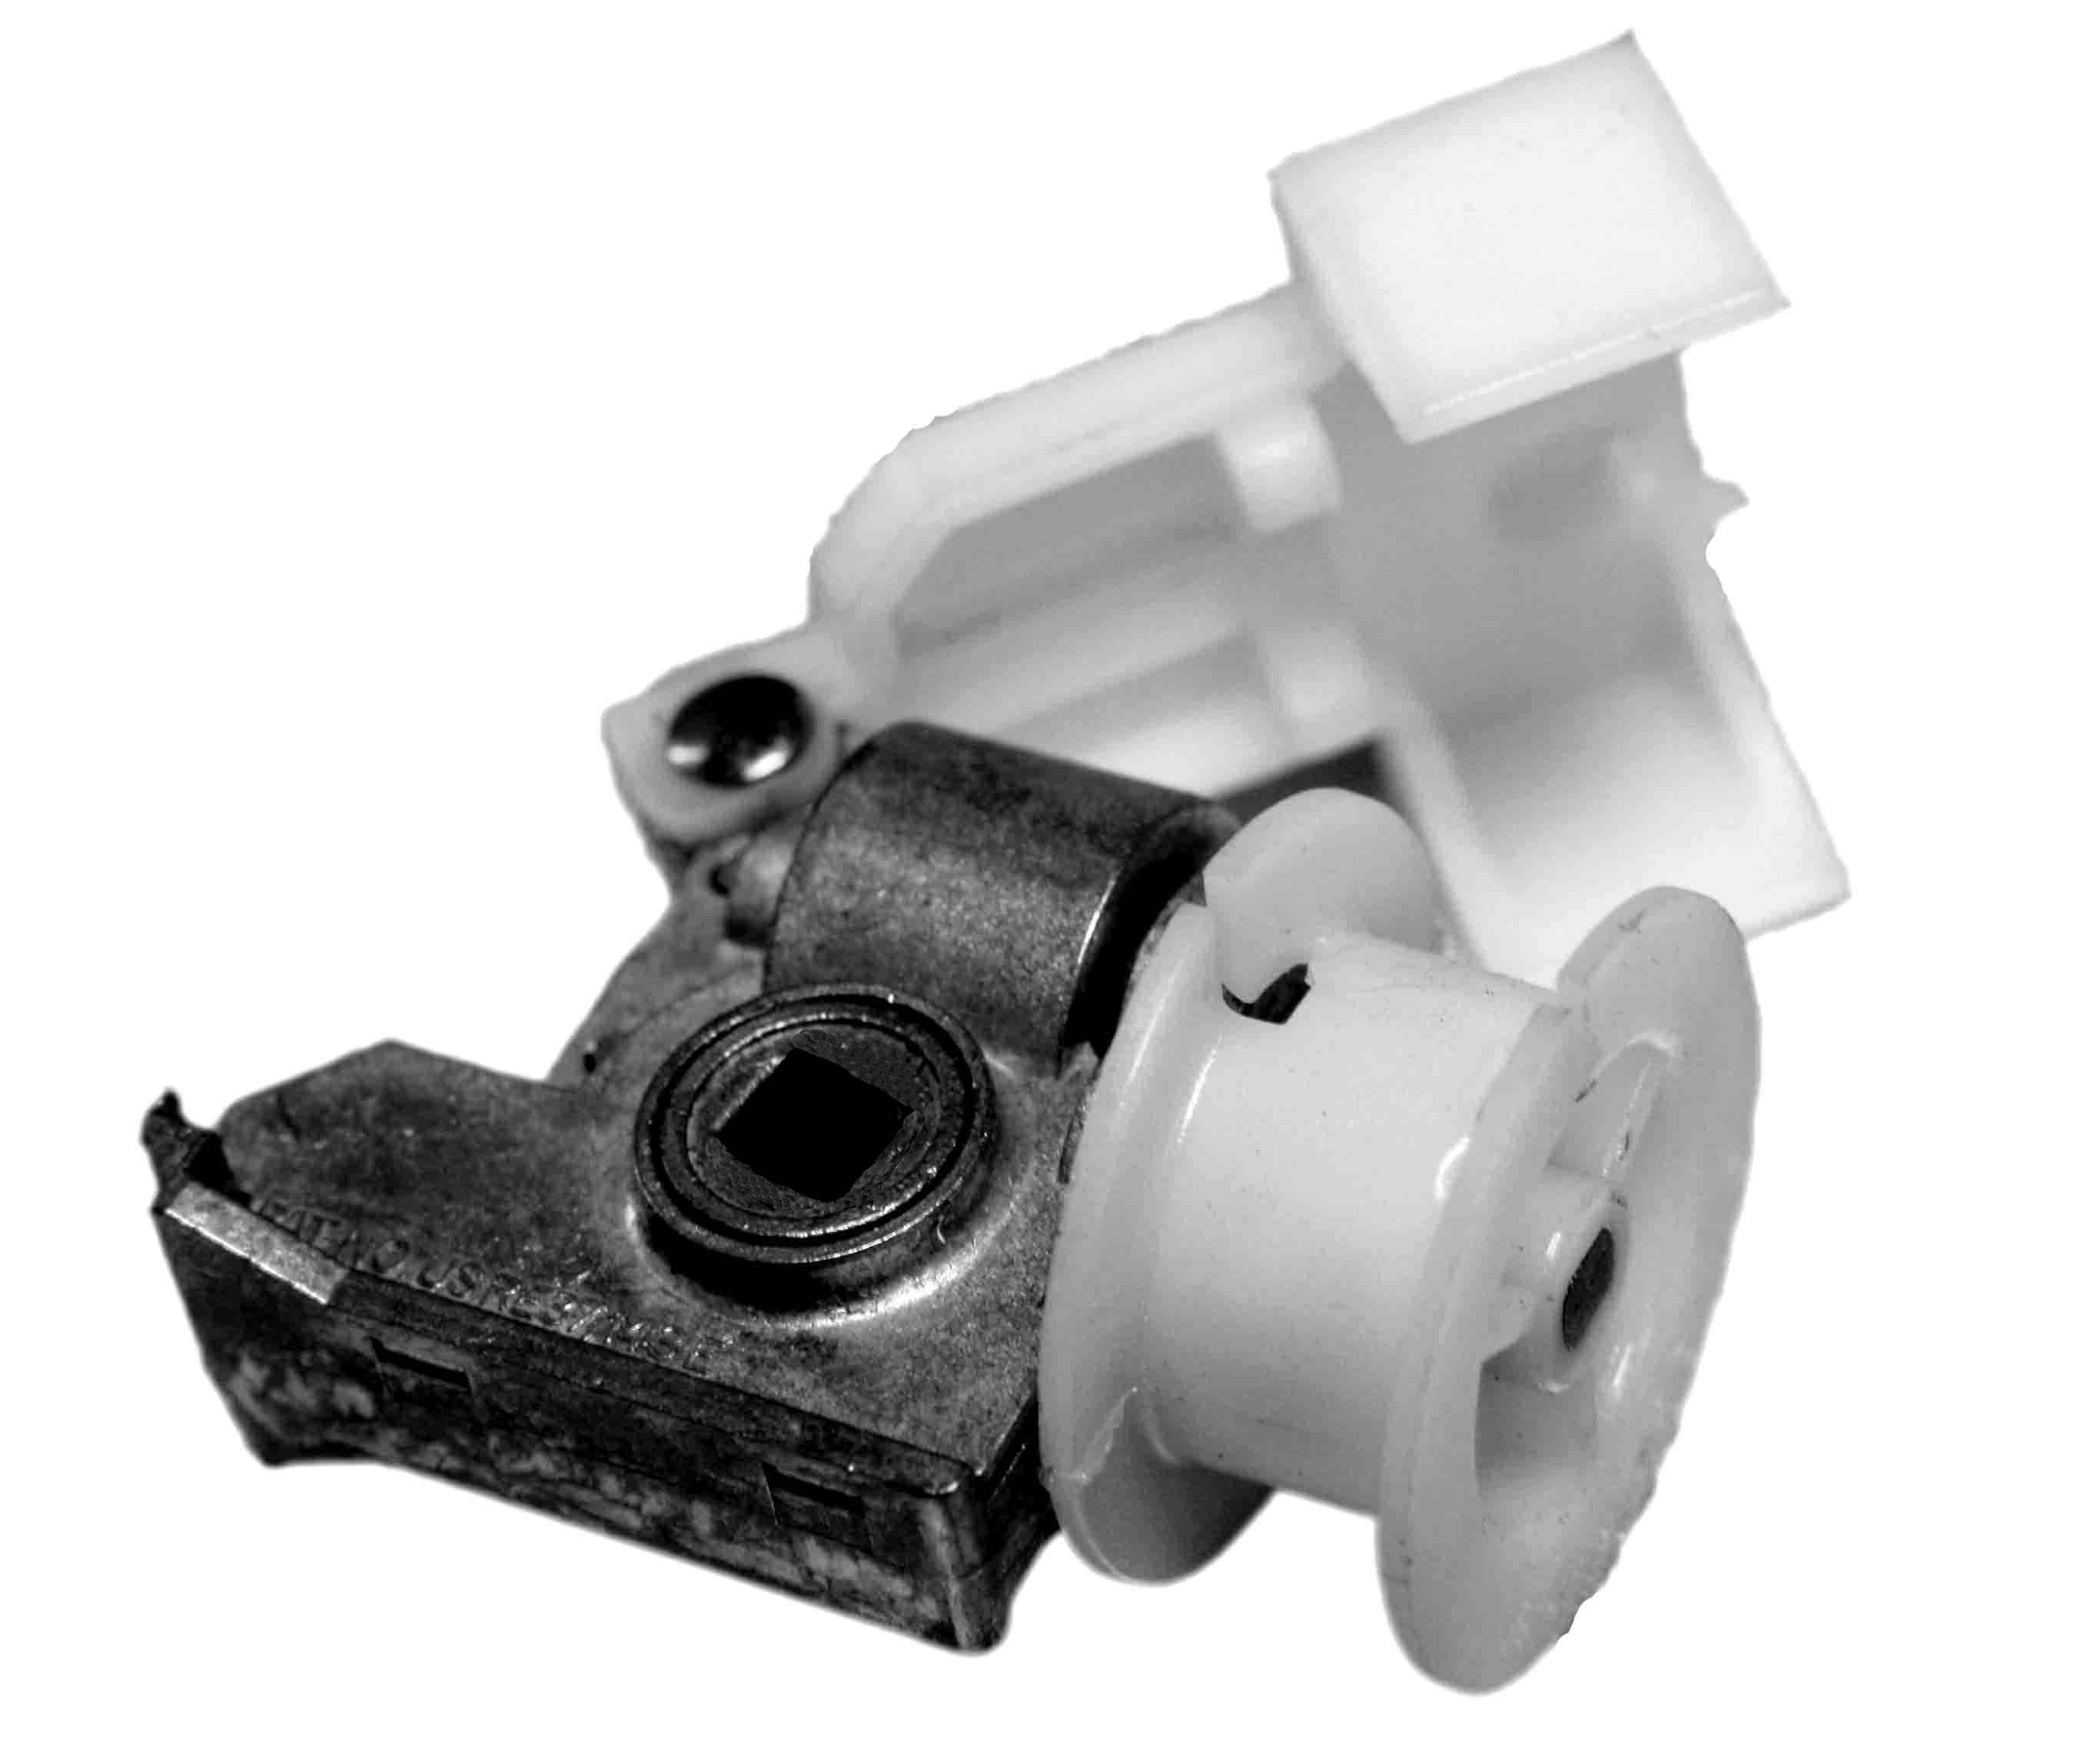

HP-CTS Cord Tilter, Zinc, Small Punch 500
HP-CTL Cord Tilter, Zinc, Large Punch 500

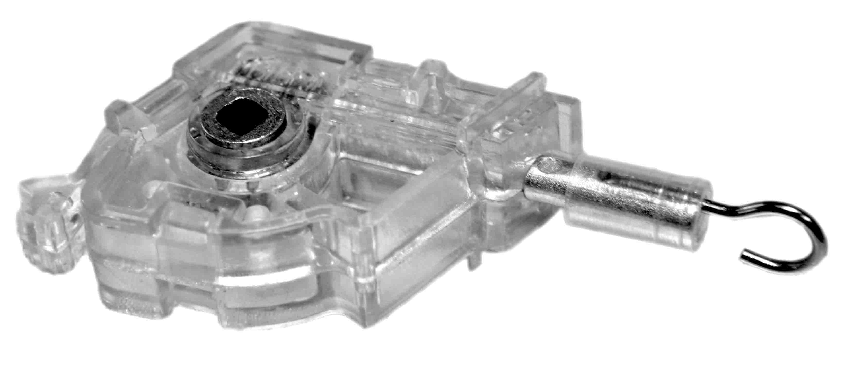
HP-WTS Wand Tilter, Zinc, Small Punch 500
HP-WTL Wand Tilter, Zinc, Large Punch 500

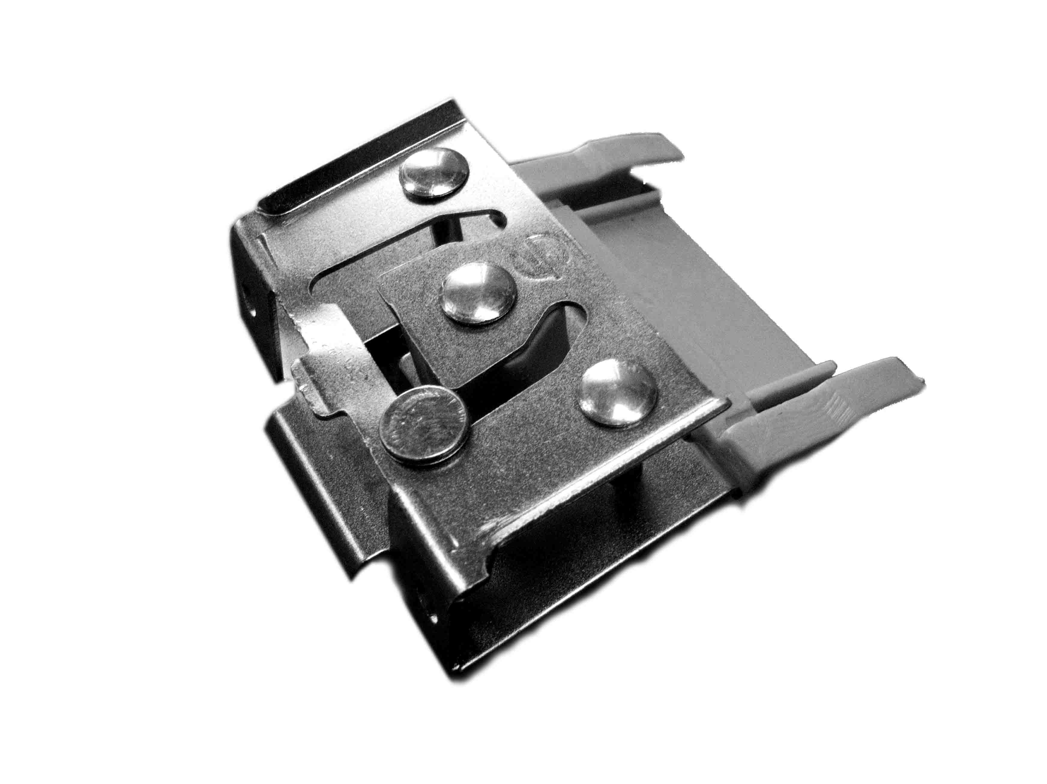

HP-CLS Cord Lock, Metal, Small Punch 500
HP-CLL Cord Lock, Metal, Large Punch 500

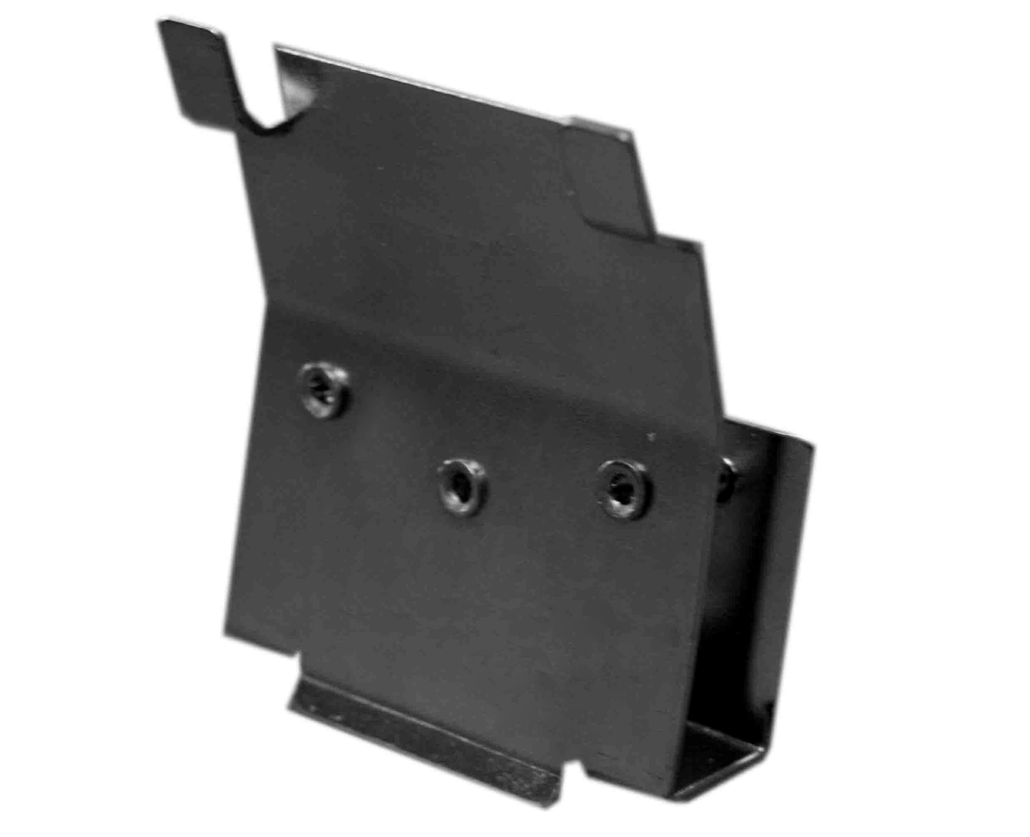

HP-CLSG Cord Lock, Swing Gate 300

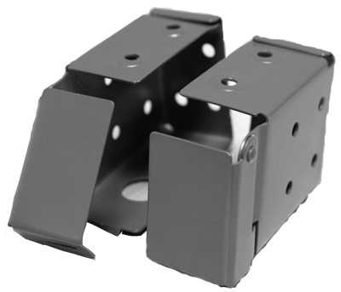
HP-BB112 Box Bracket, Alabaster 112 100 pr
HP-BB086 Box Bracket, Camel 086 100 pr
HP-BB100 Box Bracket, Vanilla 100 100 pr
HP-BB005 Box Bracket, White Gloss 005 100 pr
HP-BB205 Box Bracket, White Satin 205 100 pr

HP-CS112 Center Support, Alabaster 112 100
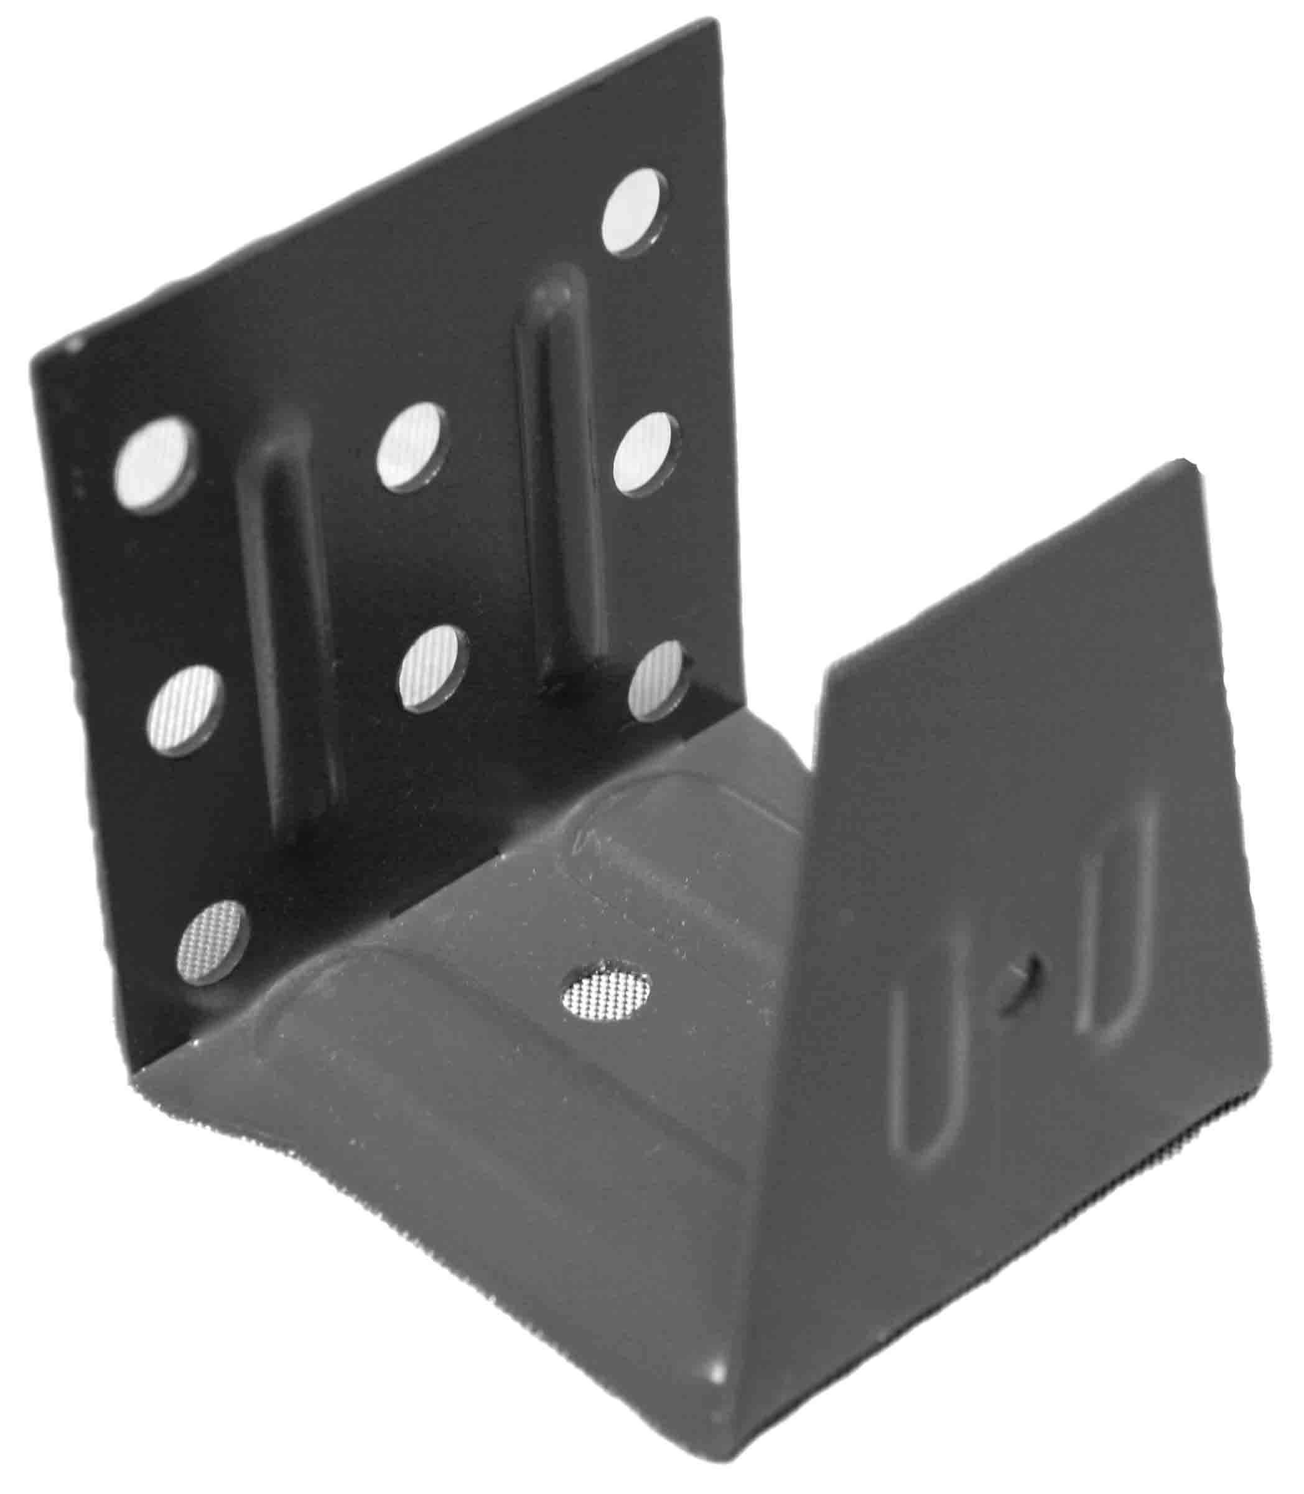
HP-CS086 Center Support, Camel 086 100
HP-CS060 Center Support, Chocolate 060 100
HP-CS100 Center Support, Vanilla 100 100
HP-CS005 Center Support, White Gloss 005 100
HP-CS205 Center Support, White Satin 205 100
HP-CSZ Center Support, Zinc 100

Common Parts & Accessories

ITEM # DESCRIPTION PCS/CT

2” Ladder
44 mm Single Loop Double Loop
HC-L44-100 HC-L44-100S HC-L44-100D Natural 100 600 ft
HC-L44-107 HC-L44-107S HC-L44-107D Alabaster 107 600 ft
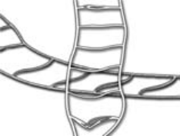
HC-L44-320 HC-L44-320S HC-L44-320D Camel 320 600 ft
HC-L44-370 HC-L44-370S HC-L44-370D Cocoa 370 600 ft
HC-L44-895 HC-L44-895S HC-L44-895D Black 895 600 ft
HC-L44-145 HC-L44-145S HC-L44-145D Biscuit 145 600 ft
HC-L44-355 HC-L44-355S HC-L44-355D Brownstone 355 600 ft HC-L44-885 HC-L44-885S HC-L44-885D Dark Bronze 885 600 ft
HC-L44-217 Dusty Pink 217 600 ft
HC-L44-638 Eruza Blue 638 600 ft
HC-L44-280 HC-L44-280S HC-L44-280D Garnet Red 280 600 ft
HC-L44-587 HC-L44-587S HC-L44-587D Hunter Green 587 600 ft
HC-L44-298 HC-L44-298S HC-L44-298D Maroon 298 600 ft
HC-L44-305 HC-L44-305S HC-L44-305D Sand 305 600 ft
HC-L44-285 Sienna 285 600 ft
HC-L44-357 HC-L44-357S HC-L44-357D Praline 357 600 ft
HC-L44-820 HC-L44-820S HC-L44-820D Squirrel Gray 820 600 ft
HC-L44-680 HC-L44-680S HC-L44-680D True Blue 680 600 ft
HC-L44-290 HC-L44-290S HC-L44-290D Terra Cotta 290 600 ft

2 ½” Ladder
54 mm Single Loop Double Loop
HC-L54-100 HC-L54-100S HC-L54-100D Natural 100 600 ft
HC-L54-107 HC-L54-107S HC-L54-107D Alabaster 107 600 ft
HC-L54-320 HC-L54-320S HC-L54-320D Camel 320 600 ft
HC-L54-370 HC-L54-370S HC-L54-370D Cocoa 370 600 ft
HC-L54-895 HC-L54-895S HC-L54-895D Black 895 600 ft

3” Ladder
67 mm Single Loop Double Loop
HC-L67-100 HC-L67-100S HC-L67-100D Natural 100 600 ft
HC-L67-107 HC-L67-107S HC-L67-107D Alabaster 107 600 ft

1.8 mm Cord 2.2 mm Cord
HC-C18-100 HC-C22-100 Natural 100 1000 yd
HC-C18-107 HC-C22-107 Alabaster 107 1000 yd
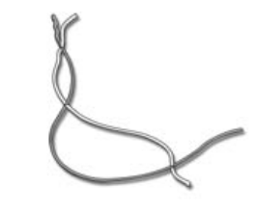
HC-C18-320 HC-C22-320 Camel 320 1000 yd
HC-C18-370 HC-C22-370 Cocoa 370 1000 yd
HC-C18-895 HC-C22-895 Black 895 1000 yd
HC-C18-145 HC-C22-145 Biscuit 145 1000 yd
HC-C18-355 HC-C22-355 Brownstone 355 1000 yd HC-C18-885 HC-C22-885 Dark Bronze 885 1000 yd
HC-C18-217 Dusty Pink 217 1000 yd
HC-C18-638 Eruza Blue 638 1000 yd
HC-C18-280 HC-C22-280 Garnet Red 280 1000 yd
HC-C18-587 HC-C22-587 Hunter Green 587 1000 yd
HC-C18-298 HC-C22-298 Maroon 298 1000 yd
HC-C18-305 HC-C22-305 Sand 305 1000 yd
HC-C18-285 HC-C22-285 Sienna 285 1000 yd
HC-C18-357 HC-C22-357 Praline 357 1000 yd
HC-C18-820 HC-C22-820 Squirrel Gray 820 1000 yd
HC-C18-680 HC-C22-680 True Blue 680 1000 yd HC-C18-290 HC-C22-290 Terra Cotta 290 1000 yd

Common Parts & Accessories

ITEM # DESCRIPTION PCS/CT

HC-CT100 1 1/2" Cloth Tape, Natural 100 50 yd
HC-CT113 1 1/2" Cloth Tape, Duck White 113 50 yd
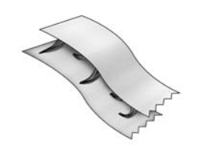
HC-CT203 1 1/2" Cloth Tape, Pink 203 50 yd
HC-CT249 1 1/2" Cloth Tape, Adobe 50 yd
HC-CT268 1 1/2" Cloth Tape, Real Red 268 50 yd
HC-CT271 1 1/2" Cloth Tape, Rust 271 50 yd
HC-CT292 1 1/2" Cloth Tape, Pompeii 292 50 yd
HC-CT298 1 1/2" Cloth Tape, Maroon 50 yd
HC-CT302 1 1/2" Cloth Tape, Taupe 302 50 yd
HC-CT307 1 1/2" Cloth Tape, White Smoke 307 50 yd
HC-CT322 1 1/2" Cloth Tape, Lt. Beige 322 50 yd
HC-CT323 1 1/2" Cloth Tape, Dk. Beige 323 50 yd
HC-CT334 1 1/2" Cloth Tape, Pecan 334 50 yd
HC-CT336 1 1/2" Cloth Tape, Toffee 336 50 yd
HC-CT349 1 1/2" Cloth Tape, Clay 349 50 yd
HC-CT376 1 1/2" Cloth Tape, Chocolate 376 50 yd
HC-CT414 1 1/2" Cloth Tape, Cornsilk 414 50 yd
HC-CT417 1 1/2" Cloth Tape, Canary 417 50 yd
HC-CT430 1 1/2" Cloth Tape, Wheat 430 50 yd
HC-CT446 1 1/2" Cloth Tape, Butterscotch 446 50 yd
HC-CT503 1 1/2" Cloth Tape, Celadon 503 50 yd
HC-CT504 1 1/2" Cloth Tape, Moss 504 50 yd
HC-CT517 1 1/2" Cloth Tape, Lt. Green 517 50 yd
HC-CT572 1 1/2" Cloth Tape, Forest 572 50 yd
HC-CT597 1 1/2" Cloth Tape, Dk. Green 597 50 yd
HC-CT613 1 1/2" Cloth Tape, Lake 613 50 yd
HC-CT627 1 1/2" Cloth Tape, Provence Blue 627 50 yd
HC-CT652 1 1/2" Cloth Tape, Alice Blue 652 50 yd
HC-CT661 1 1/2" Cloth Tape, Atlantic Blue 661 50 yd
HC-CT685 1 1/2" Cloth Tape, Midnight Blue 685 50 yd
HC-CT751 1 1/2" Cloth Tape, Twilight 751 50 yd
HC-CT822 1 1/2" Cloth Tape, Gray 822 50 yd
HC-CT823 1 1/2" Cloth Tape, Silver 823 50 yd
HC-CT897 1 1/2" Cloth Tape, Black 897 50 yd

HC-PT250 Plastic Tassel 250 Bamboo 250
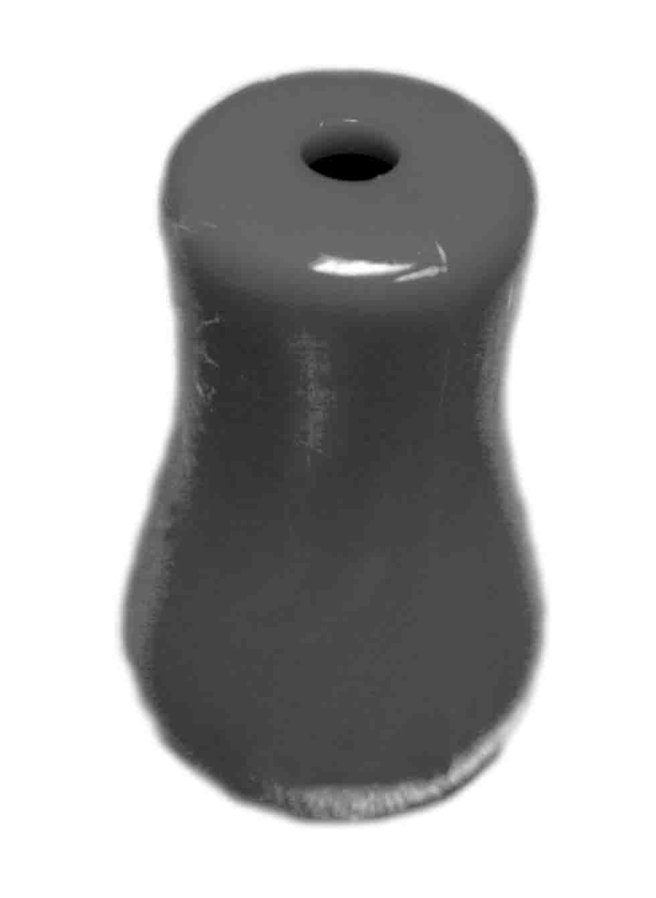
HC-PT256 Plastic Tassel 256 Chestnut 250
HC-PT257 Plastic Tassel 257 Mahogany 250
HC-PT251 Plastic Tassel 251 Natural 250
HC-PT254 Plastic Tassel 254 Oak 250
HC-PT210 Plastic Tassel 210 Oyster 250
HC-PT203 Plastic Tassel 203 White 250
HC-PT306 Plastic Tassel 306 Clear 250

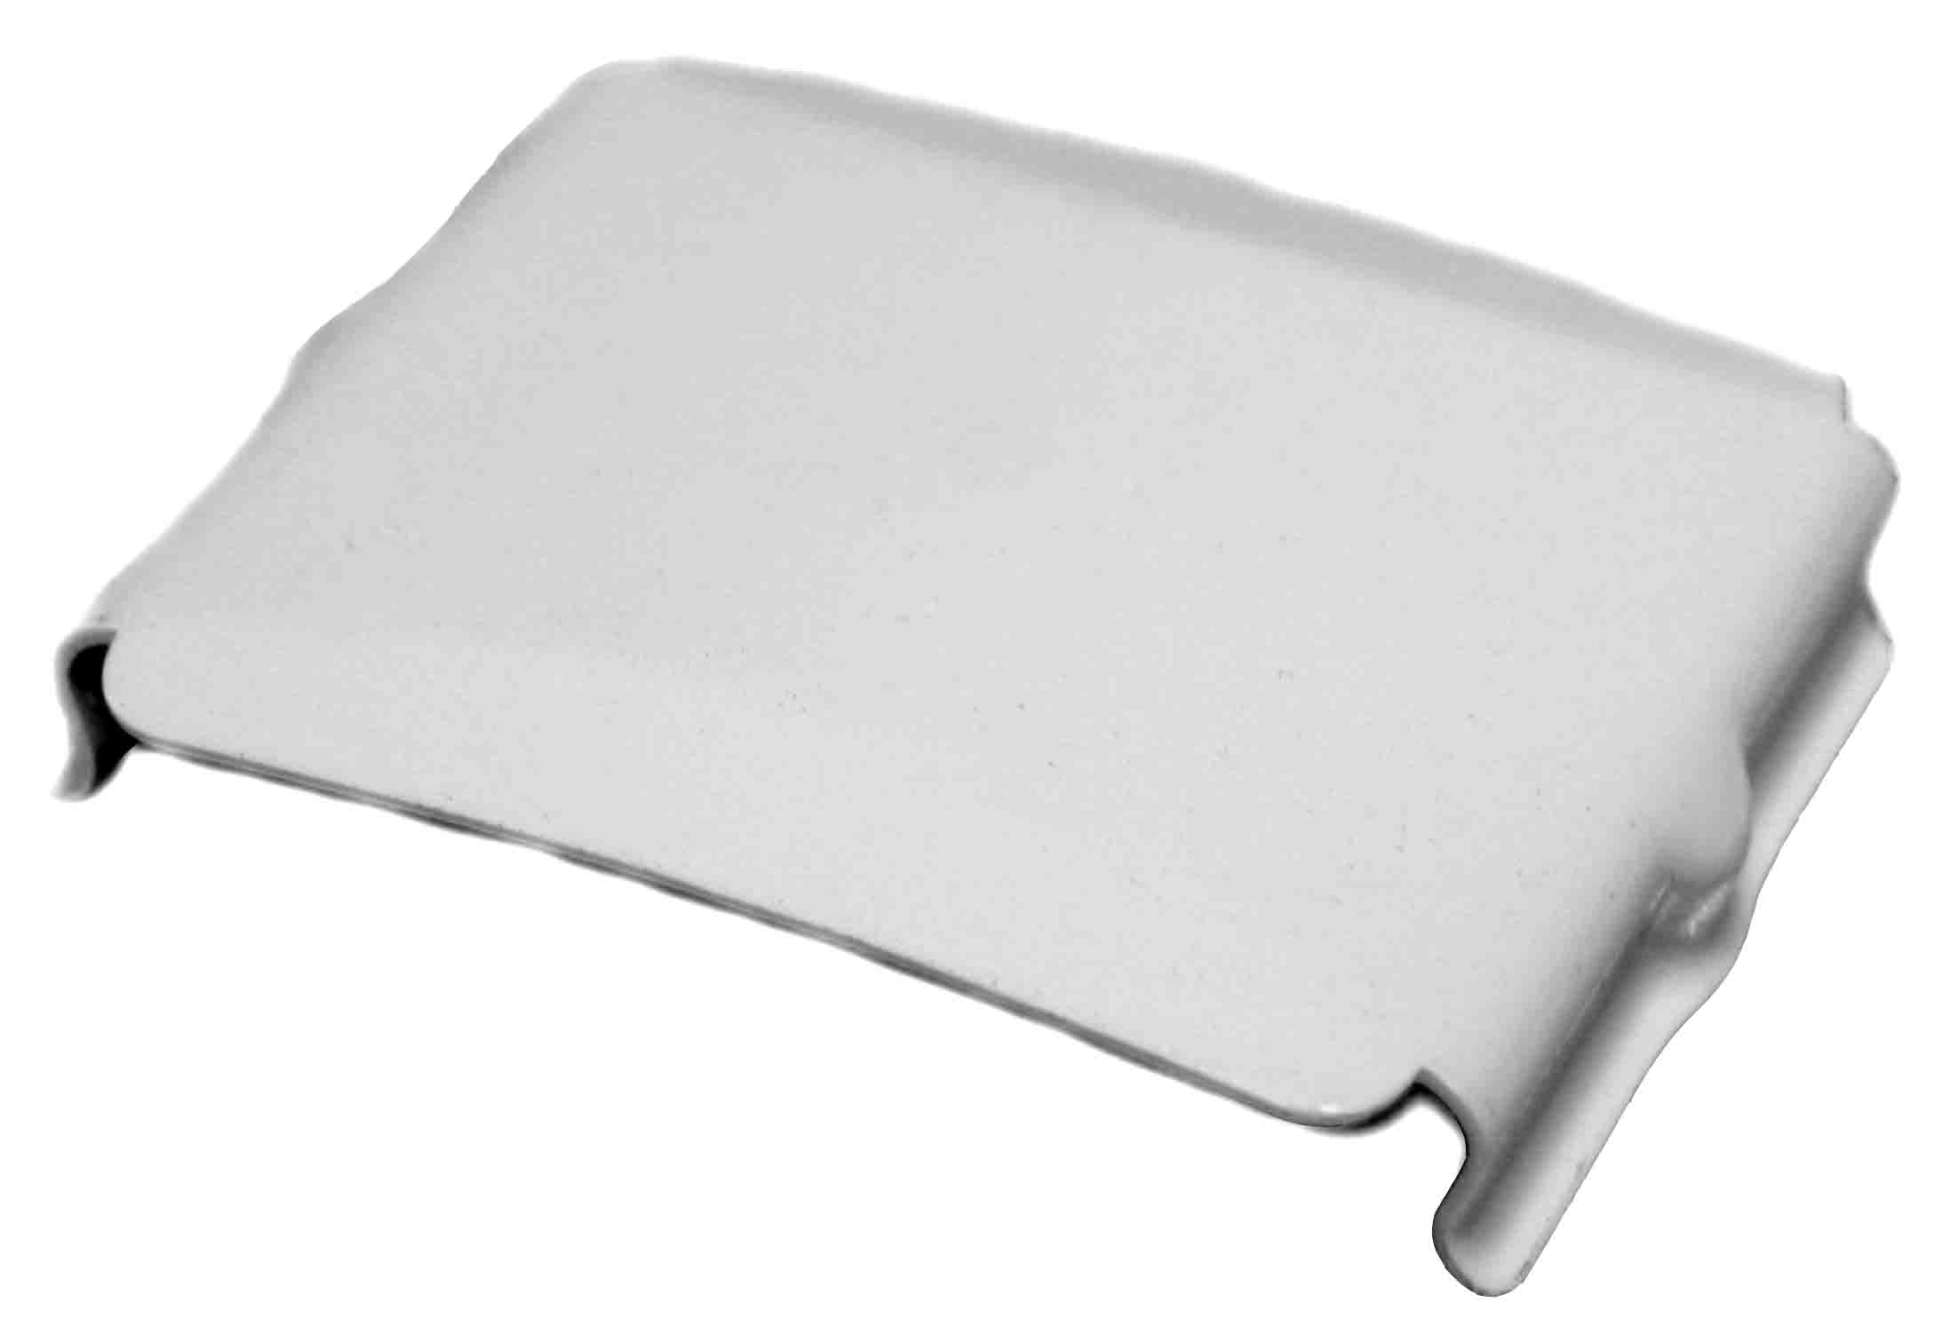
HC-TL112 Tape Lock, Alabaster 112 1000
HC-TL086 Tape Lock, Camel 086 1000
HC-TL060 Tape Lock, Chocolate 060 1000
HC-TL005 Tape Lock, White Gloss 005 1000
HC-TL205 Tape Lock, White Satin 205 1000

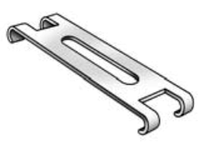
HC-TSC2 Top Slat Clip, 2" Plastic, Clear 1000
HC-TSC25 Top Slat Clip, 2 ½ " Plastic, Clear 1000
HC-TSC3 Top Slat Clip, 3" Plastic, Clear 1000

Common Parts & Accessories

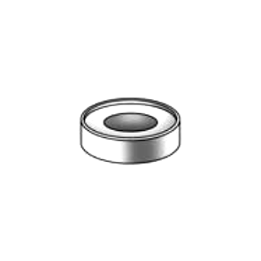
ITEM # DESCRIPTION PCS/CT

HC-CS Cord Stop, Round, Clear 1000

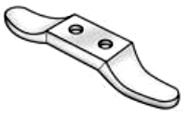

HC-CCL Cord Cleat, Large, Clear 500
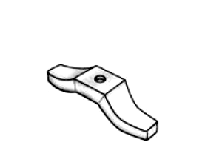

HC-CCS Cord Cleat, Small, Clear 500

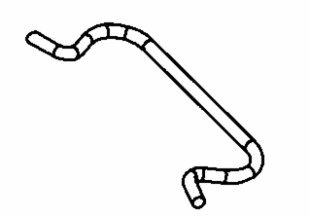

HC-CSP Cord Separator 1000

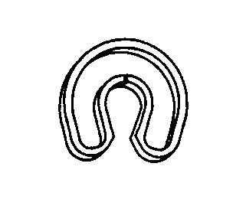

HC-RC Retainer Clip 1000

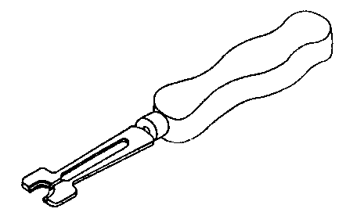
HC-RT Retainer Clip Tool 1 pc

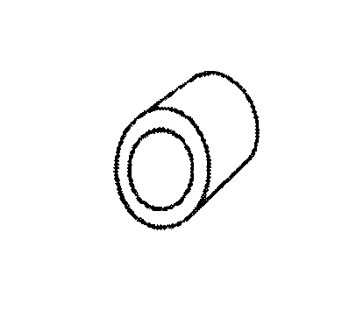
HC-RSS Rubber Stopper, Square 1000
HC-RSH Rubber Stopper, Hex 1000

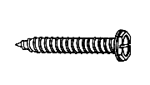

HC-IS Installation Screw 5000



HC-CRB05 Cord Retainer Button, EZ Button, 9/32", Translucent 500

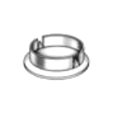
HC-CRB34 Bottom Rail Button 3/4" Clear 1000
HC-CRB38 Bottom Rail Button 3/8" Translucent 1000

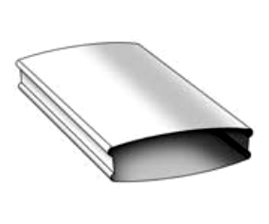
HC-BRS112 Bottom Rail, 2" Steel Lock Seam, 16’, Alabaster 112 12
HC-BRS086 Bottom Rail, 2" Steel Lock Seam, 16’, Camel 086 12
HC-BRS060 Bottom Rail, 2" Steel Lock Seam, 16’, Chocolate 060 12
HC-BRS005 Bottom Rail, 2" Steel Lock Seam, 16’, White Gloss 005 12
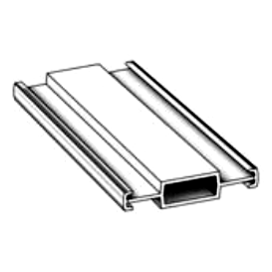
HC-BRS205 Bottom Rail, 2" Steel Lock Seam, 16’, White Satin 205 12

HC-BRPVC Bottom Rail, 2" PVC, 12’, White 25
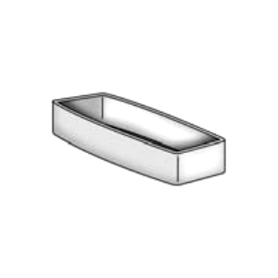

HC-BRC112 Bottom Rail, End Cap, PVC, Alabaster 112 1000
HC-BRC086 Bottom Rail, End Cap, PVC, Camel 086 1000
HC-BRC060 Bottom Rail, End Cap, PVC, Chocolate 060 1000
HC-BRC205 Bottom Rail, End Cap, PVC, White Satin 205 1000
HC-BRC306 Bottom Rail, End Cap, PVC, Clear 306 1600

Common Parts & Accessories

ITEM # DESCRIPTION PCS/CT
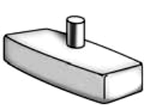

HC-BRP306 Bottom Rail, End Cap with Pin, Clear 306 1600

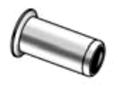
HC-BG38 Brass Grommet, 3 mm x 8 mm 1000
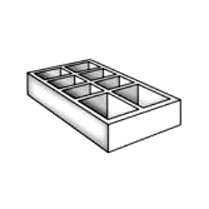
HC-BG48 Brass Grommet, 4 mm x 8 mm 1000

HC-SP Spacer, 3/8 Block, Waffle Weave 500

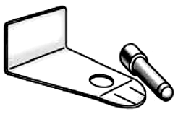

HC-HD Hold Down, Metal with Pin 500

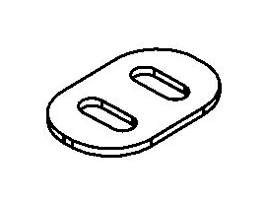
HC-CES Cord Equalizer, Small 1000
HC-CEL Cord Equalizer, Small 1000

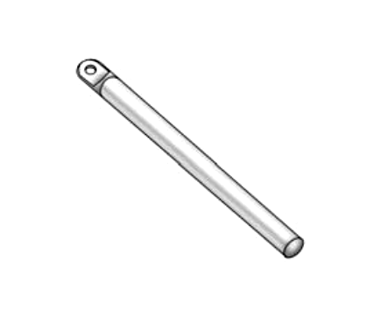
24” Plastic Wand 36” Plastic Wand
HC-PW250-24 HC-PW250-36 Bamboo 250 50
HC-PW256-24 HC-PW256-36 Chestnut 256 50
HC-PW257-24 HC-PW257-36 Mahogany 257 50 HC-PW251-24 HC-PW251-36 Natural 251 50 HC-PW254-24 HC-PW254-36 Oak 254 50
HC-PW210-24 HC-PW210-36 Oyster 210 50
HC-PW203-24 HC-PW203-36 White 203 50
HC-PW306-24 HC-PW306-36 Clear 306 50

48” Plastic Wand 60” Plastic Wand
HC-PW250-48 HC-PW250-60 Bamboo 250 30
HC-PW256-48 HC-PW256-60 Chestnut 256 30
HC-PW257-48 HC-PW257-60 Mahogany 257 30 HC-PW251-48 HC-PW251-60 Natural 251 30 HC-PW254-48 HC-PW254-60 Oak 254 30
HC-PW210-48 HC-PW210-60 Oyster 210 30
HC-PW203-48 HC-PW203-60 White 203 30
HC-PW306-48 HC-PW306-60 Clear 306 30

Warranty 3 YEARS NON-TRANSFERABLE LIMITED

NomiStar, in respect of blinds manufactured by NomiStar warrants to you the original purchaser of Products, that subject to the terms and conditions herein contained, the Products are and will be free from defects in materials and workmanship. This warranty will remain in effect for three (3) years as long as you are the original purchaser of the Products. All failures to Products covered by this warranty will be repaired, replaced or restored by NomiStar in accordance with the terms and conditions of this warranty. By acceptance and use of the Products, you agree with
NomiStar’s liability, and replacement of the Products at NomiStar’s option, as provided herein.

This warranty is void if parts and components not supplied by NomiStar are used. Failure, damage, defects or malfunctions resulting from misuse, abuse, negligence, alteration, accident, lack of proper maintenance, repairs, impact of foreign objects, improper installation (including louvers installed closer than ten inches from any heat source), acts of God and other causes beyond NomiStar’s control shall not be considered defects under this warranty and are not covered in any way by this warranty. This warranty also does not apply to conditions resulting from normal wear and tear. NomiStar shall not be liable for inconvenience, labor, loss of time, maintenance, removal or reinstallation of the Products or other incidental, special or consequential damages arising in relation to the purchase or use of the Products. This warranty is void if the surface of the Products is covered with paint or any other foreign material. This warranty is void if Products are
cleaned with any process other than mild detergent and a damp cloth on faux and vinyl, or a soft dry cloth for real wood products.

Warranty Claims:
The owner must give prompt notice of any defects to obtain warranty service. Should the Products contain a manufacturing defect promptly contact the NomiStar, Customer Care Center at any of the addresses herein to register the claim with a customer care representative. NomiStar will require proof of purchase, a detailed description of the defect, Product serial number and a clear photograph of the defective part(s) (or actual part(s) if requested). If a return is authorized by NomiStar, please clearly indicate the return authorization number (“R/A”) on all materials sent to NomiStar and make sure to use the carrier requested by NomiStar. If a different carrier is used, NomiStar will not be responsible for the freight charges incurred. All R/A numbers are valid for a period of 30 days from the date issued. NomiStar will, at its option, repair or replace such defective part(s) free of charge, including freight charges within the United States and Canada. NomiStar’s shipping service will deliver parts under this warranty within 8 to 10 business days. This warranty is not applicable outside of the United States and Canada.

Shipping Instructions:
If requested for inspection, defective parts must be shipped to NomiStar, Customer Care, shipping address will be provided upon approval. Please include the following information in the package: full name, address, telephone number, Product model number and part number. When returning product please use an insured method of delivery such as
Fed Ex insured accordingly, with the signature option on, or your preferred courier service. You must pay for return shipment, as we will not accept C.O.D. returns or any additional shipping charges, which may occur when packages are entering into the United States or Canada.

NomiStar reserves the right to discontinue or change any of its Products, including colors, without giving notice to the purchaser. Should a Product covered by this warranty be unavailable, NomiStar reserves the right to substitute a Product that is of equal quality according to NomiStar’s sole discretion or to refund the portion of the original price for defective part of the Product reflective of its original contribution to the cost of the Products.

THIS WARRANTY IS GIVEN IN LIEU OF ALL OTHER WARRANTIES, LIABILITES OR OBLIGATIONS OF NomiStar EITHER EXPRESSED OR IMPLIED, EXCEPT THAT THE DURATION OF ANY IMPLIED WARRANTIES OF MERCHANTABILITY AND FITNESS FOR A PARTICULAR PURPOSE ARE LIMITED IN TIME TO THE DURATION OF THIS WARRANTY. NomiStar SHALL IN NO EVENT BE LIABLE FOR CONSEQUENTIAL OR INCIDENTAL OR SPECIAL DAMAGES OF ANY KIND FOR BREACH OF ANY EXPRESS WRITTEN OR ORAL OR IMPLIED WARRANTY ON PRODUCTS. YOUR EXCLUSIVE REMEDY SHALL BE ENFORCEMENT OF THIS WARRANTY UPON THE TERMS AND CONDITIONS HEREIN CONTAINED. NO REPRESENTATIVE OF NomiStar OR ITS DISTRIBUTORS OR DEALERS ARE AUTHORIZED TO MAKE ANY CHANGE OR MODIFICATION TO THIS WARRANTY.

Some jurisdictions do not allow limitation on how long an implied warranty lasts, so the limitations contained herein above may not apply to you. Some jurisdictions do not allow the exclusion or limitation on consequential or special damage, so the above limitations or exclusions may not apply to you. This warranty gives you specific legal rights, and you may also have other rights, all of which vary from jurisdiction to jurisdiction.


